INVENTION: INTEGRATED MULTIPLEX PCR SYSTEM WITH AUTOMATED SAMPLE PROCESSING
FIELD OF THE INVENTION
The present invention relates to molecular diagnostics, specifically to a fully integrated multiplex PCR system designed to automate the entire sample-to-result workflow. The system enables pathogen detection from faecal specimens using a microfluidic Biochip for sample pre-processing, DNA extraction, and multi-stage PCR amplification.
BACKGROUND OF THE INVENTION
Current molecular diagnostic tools for pathogen detection, especially in stool samples, often rely on central laboratory equipment and skilled technicians, making them impractical for on-site diagnostics or low-resource settings. Traditional methods involve multiple steps such as manual DNA extraction, purification, and amplification, which can be error-prone and time-consuming.
The COVID-19 pandemic further highlighted the need for self-contained diagnostic devices capable of delivering rapid and reliable results without laboratory dependency. The invention aims to address these limitations with an integrated, automated system that simplifies sample handling, streamlines multiplex PCR processes, and provides real-time pathogen detection in a compact format.
SUMMARY OF THE INVENTION
The invention is a fully automated, sample-to-result multiplex PCR (mPCR) system designed for detecting pathogens in faecal specimens. It eliminates the need for specialized equipment by integrating all necessary functions—sample pre-processing, DNA extraction, amplification, and fluorescence-based detection—into a compact, modular device.
The system features a novel microfluidic Biochip that orchestrates fluid handling, centrifugation, ultrasonic lysis, and multi-channel optical detection. The Biochip’s sequential chambers enable cell lysis, nucleic acid binding, washing, and qPCR amplification, enhancing efficiency and accuracy. With modular mechanical, thermal, and optical subsystems, the device is optimized for high-throughput pathogen detection, making it suitable for diverse clinical settings.
BRIEF DESCRIPTION OF FIGURES
In order that the invention may be fully understood and readily put into practical effect there shall now be described by way of non-limitative example only exemplary embodiments of the present invention, the description being with reference to the accompanying illustrative drawings.
Fig. 1 is the overview of the mPCR system components and their arrangement within the modular casing.
Fig. 2 is the diagram of the Biochip, showing chambers for lysis, magnetic bead storage, wash stations, and PCR amplification.
Fig. 3 is the schematic of the thermal system with polyimide flexible heater and Peltier coolers for precise temperature cycling.
Fig. 4 is the optical system setup showing the LED excitation source, dichroic mirrors, and multi-channel fluorescence detection configuration.
Fig. 5 is the Flowchart of the system’s operational workflow, from sample loading to result generation.
BRIEF DESCRIPTION OF FIGURES
System Overview The mPCR system automates pathogen detection in fecal samples, performing all required sample preparation, DNA extraction, and PCR analysis within a single, compact unit. The system integrates a specialized Biochip with automated fluidic pathways and processing chambers to facilitate high-throughput, contamination-free diagnostics.
Modules and Components
- Sample Collection and Biochip Preparation
The Biochip, loaded with a fecal specimen, initiates sample processing by mixing with preloaded lysis buffer. It contains dedicated chambers and pathways to support each stage, from cell lysis to PCR amplification.
- Mechanical System
The mechanical subsystem encompasses:
- Centrifuge: Operates at 1,000 rpm to isolate DNA from debris.
- Liquid Handler: Transfers supernatant to stages for DNA extraction.
- Ultrasonic Probe: Generates high-frequency waves (>20 kHz) for cell lysis.
- Magnetic Tip: Controls magnetic beads for DNA binding, transferring them through washing and elution stages.
- Thermal System
Key thermal components include:
- Flexible Heater: Provides stable PCR cycling with a range of -40°C to 200°C.
- Peltier Coolers: Control cooling, regulated with heat sinks and fans.
- Heating Block and Thermal Sensor: Ensure precise temperature modulation during PCR amplification.
- Optical System
The optical module facilitates fluorescence detection, essential for quantifying amplified DNA:
- LED Light Source: Excites dyes at target wavelengths.
- Detection Channels: Multi-channel configuration (ROX, Cy5, FAM) allows for multiplexed pathogen detection.
- Dichroic Mirrors and Filters: Enable precise signal isolation from different dyes, improving specificity.
- Biochip Design
The Biochip is a key component, designed with separate chambers for each processing step:
- Sample and Lysis Chamber: Conducts ultrasonic lysis to release DNA.
- Bead Binding and Wash Chambers: Sequential chambers purify DNA through washing.
- Elution Tube and PCR Chamber: Prepare DNA for PCR amplification.
Operational Workflow
- Sample Loading: The operator loads a faecal specimen into the Biochip.
- Automated Processing: The system conducts cell lysis, centrifugation, and magnetic bead binding.
- DNA Elution and PCR Prep: Purified DNA is eluted and combined with PCR reagents.
- Thermal Cycling and Detection: The system conducts thermal cycling, capturing real-time fluorescence signals.
- Result Analysis: Fluorescence intensity is processed and quantified, providing diagnostic output.
CLAIMS
- A fully integrated sample-to-result PCR system comprising:
  - A microfluidic Biochip supporting multi-stage sample processing, DNA extraction, and PCR preparation.
  - Mechanical components for cell lysis, liquid handling, and magnetic bead manipulation.
  - A thermal system with controlled heating and cooling modules.
  - An optical system configured to detect fluorescence for DNA quantification.
- The Biochip in claim 1 includes:
- A sample and lysis chamber designed for ultrasonic lysis.
- Sequential wash chambers for contaminant removal.
- Elution and PCR chambers for DNA amplification.
- The thermal system in claim 1 includes:
  - A flexible heater and Peltier cooler for stable temperature cycling.
  - A thermal sensor for precise temperature monitoring.
- The optical system in claim 1 utilizes multi-band filters and dichroic mirrors to measure fluorescence from multiple fluorophores.
- The optical system in claim 1 comprises a multi-channel configuration, enabling multiplexed detection of at least three fluorescent dyes within a single PCR sample for pathogen identification.
ABSTRACT
The invention presents a compact, automated sample-to-result multiplex PCR system designed for pathogen detection from faecal specimens, eliminating the need for specialized laboratory equipment. Utilizing a microfluidic Biochip, the system integrates DNA extraction, purification, PCR amplification, and real-time fluorescence-based detection within one device. The Biochip’s design includes chambers for cell lysis, magnetic bead-based DNA binding, sequential washing, and elution, followed by thermal cycling and fluorescence detection. The system’s modular design, with mechanical, thermal, and optical components, facilitates rapid, accurate pathogen detection for point-of-care and decentralized diagnostic applications.

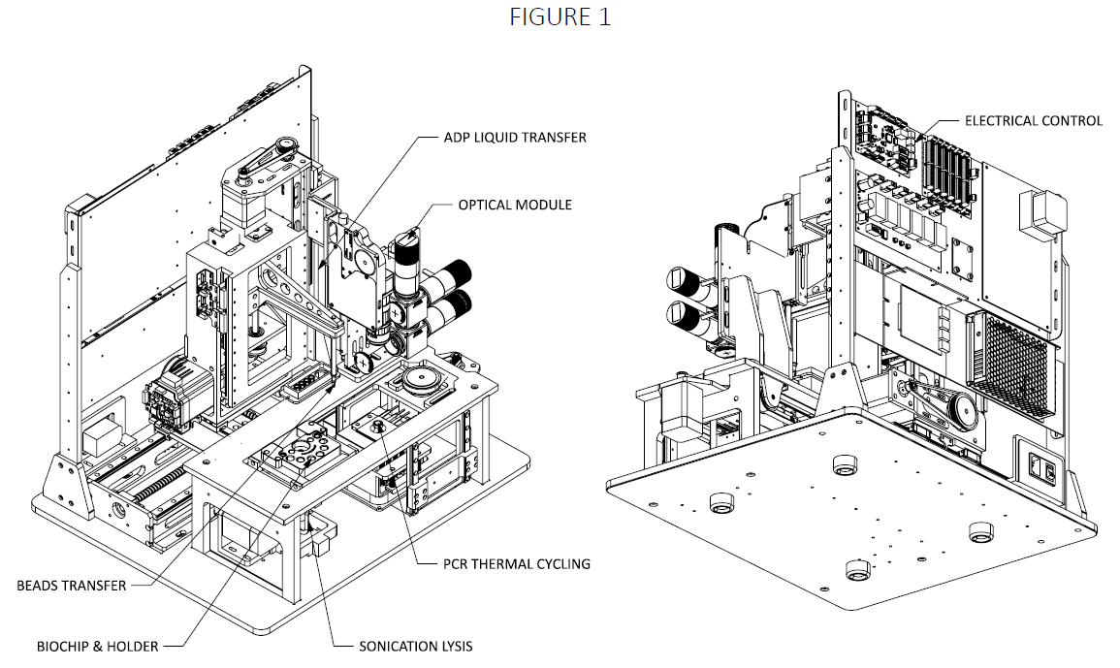
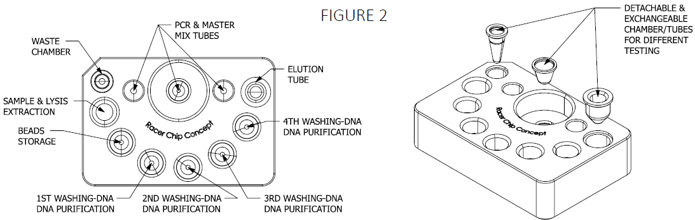
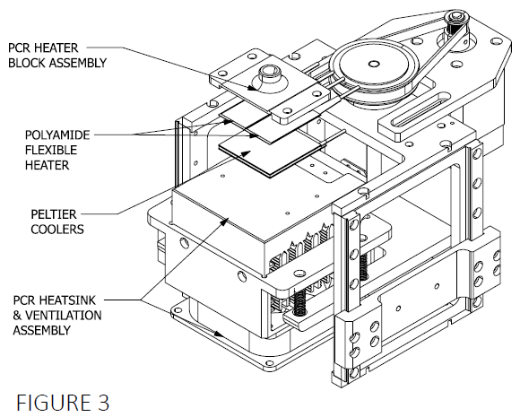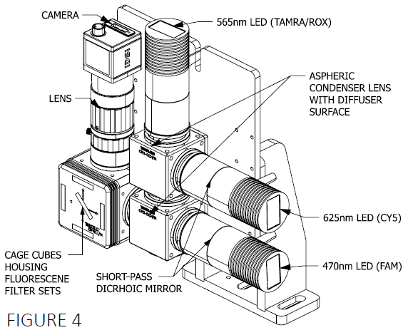
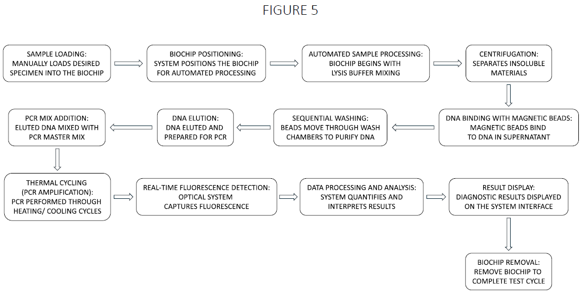
[PATENT DRAFT TO FURTHER UPDATE BASED ON EVERY PARTIES’S COMMENT AFTER REVIEW.]

