Detailed description of drawing
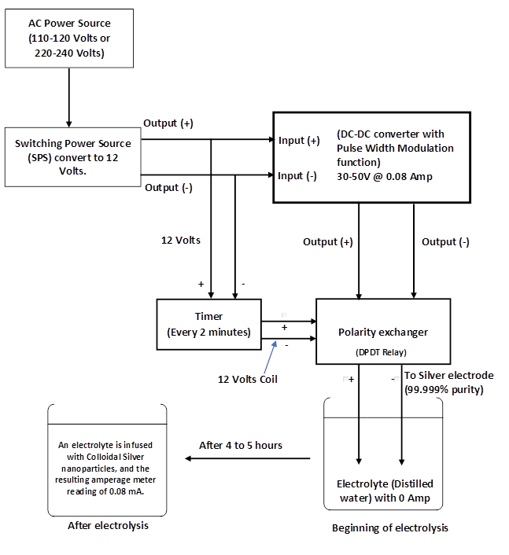

Figure 1
The schematic diagram of the Regulated Adjustable Power Supply Generator and its methodology employed to produce colloidal silver nanoparticles, as presented in Figure 1.

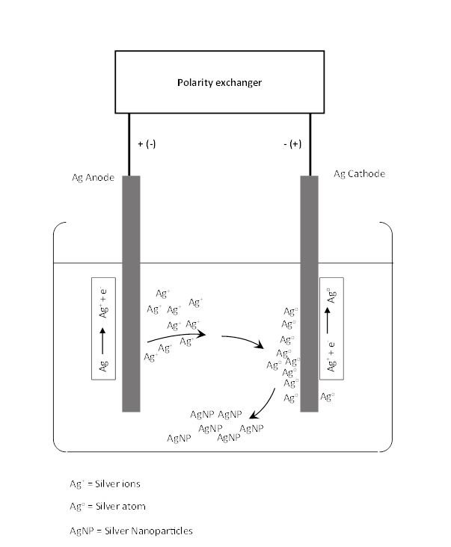
Detailed description of drawing

Figure 2
The silver atoms generated at the cathode experiencing nucleation and subsequent growth, which ultimately leads to the formation of the colloidal silver nanoparticles, as illustrated in figure 2.

Detailed description of drawing

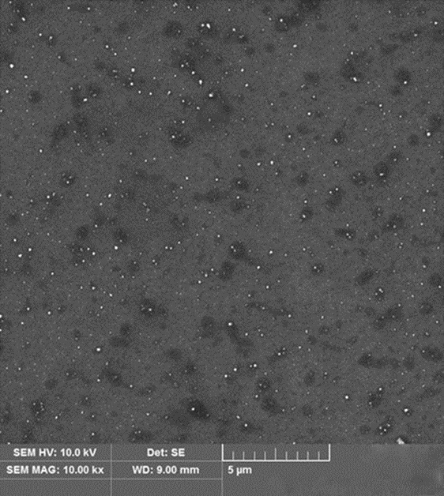
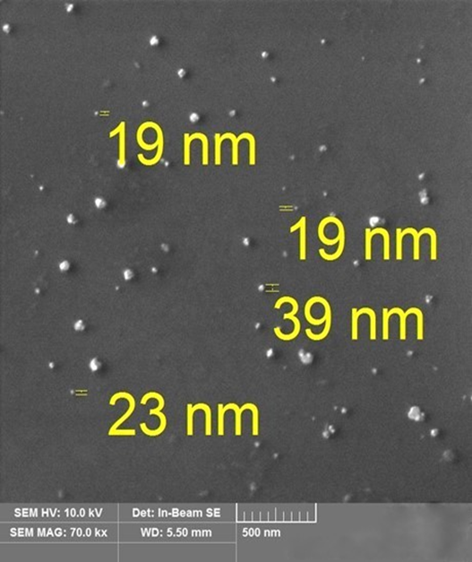

Figure 3

Scanning Electron Microscopy Results for Silver Nanoparticle

Detailed description of drawing
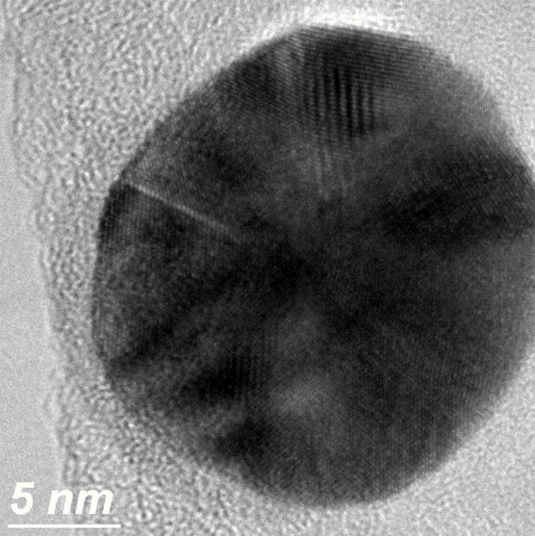
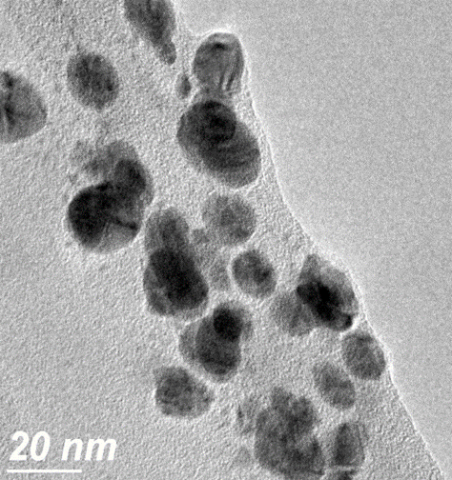
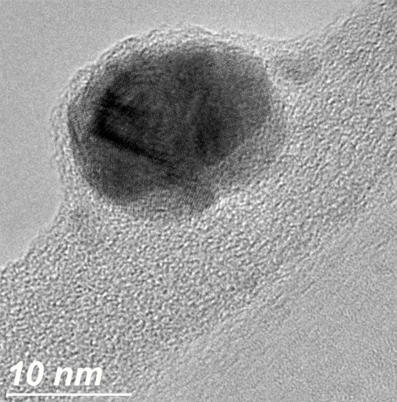

Figure 4

Transmission Electron Microscopy of silver nanoparticle

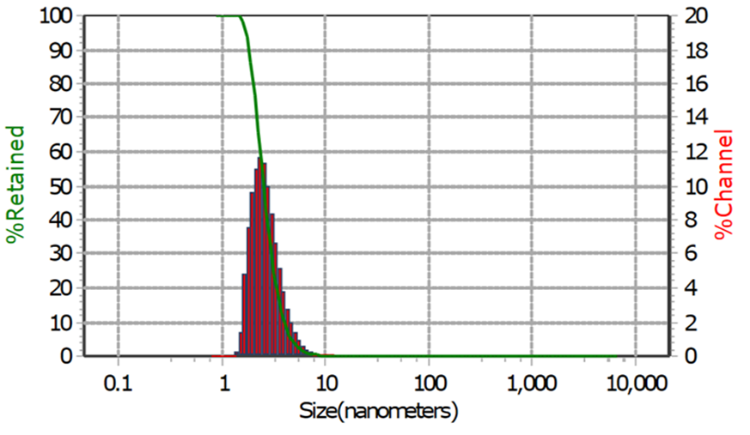
Detailed description of drawing
Summary |  | Percentiles
Data | Value | %Title | Size (nm)
MV (nm) | 2.780 | 10.00 | 4.01
MN (nm) | 2.190 | 20.00 | 3.36
MA (NM) | 2.520 | 30.00 | 3.01
CS | 2381 | 40.00 | 2.743
SD | 0.820 | 50.00 | 2.532
PDI | 50.57 | 60.00 | 2.354
Mz | 2.680 | 70.00 | 2.179
σι | 0.862 | 80.00 | 2.006
Ski | 358.6 | 90.00 | 1.822
Kg | 1146 | 95.00 | 1.705

Figure 5

Particle size distribution results of colloidal silver nanoparticles solution

Measured Data
Zeta Potential | 32.8 mv
Polarity | Negative
Mobility | 2.5 µ/s/V/sm
Conductivity | 139 µS/cm
Field Strength | 9.9 kV/m
SOP
Zeta Run Time | 30 sec
Detailed description of drawing

Figure 6
Zeta potential results of colloidal silver nanoparticle solution

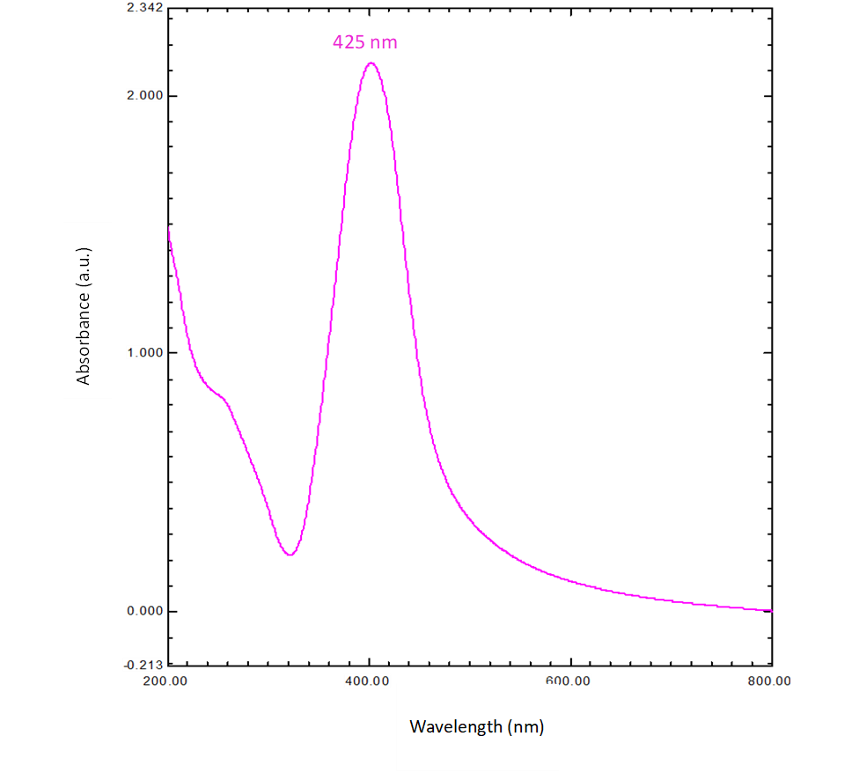
Detailed description of drawing

Figure 7
UV-VIS (Ultraviolet-Visible) spectroscopy results for of silver nanoparticles colloidal solution.

