Illustrations and Drawings

Figure 1. Schematic depiction of possible irregularities in the core-shell structures obtained during the “etching” of calcium carbonate core combined with precipitation of calcium phosphate shell.

Figure 2. Schematic representation of an active reaction zone during the interaction of solid CaCO₃ with orthophosphate anions penetrating from the outer aqueous medium; reaction zone is congested between the core and the growing shell.

Figure 3. Schematic of the active reaction zone during the interaction of the solubilized calcium ion source with solubilized orthophosphate anions available in the aqueous medium.

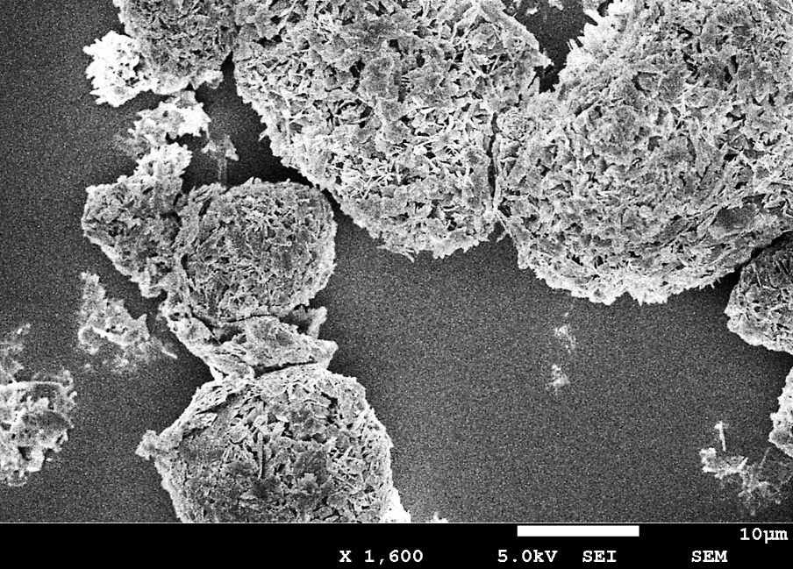
Figure 4. SEM image of the particles prepared according to Example 1.

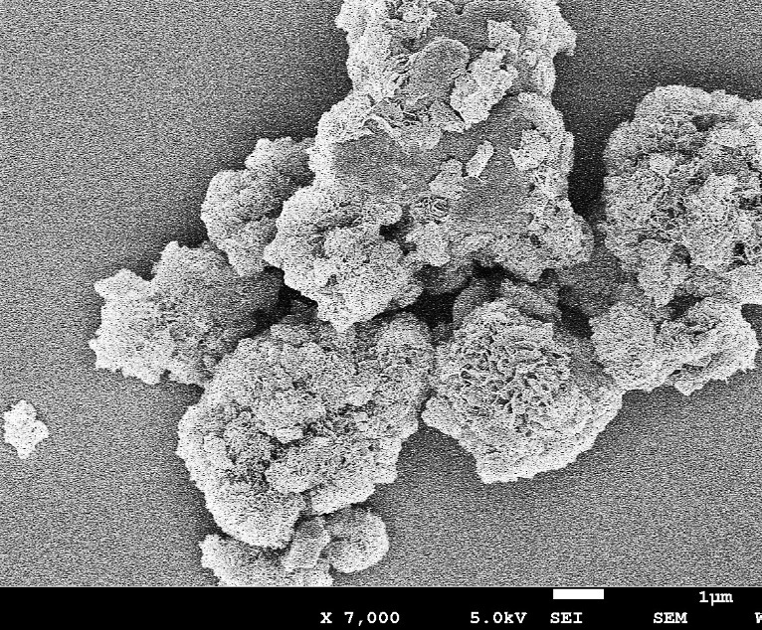
Figure 5. SEM image of the particles prepared according to Example 2.

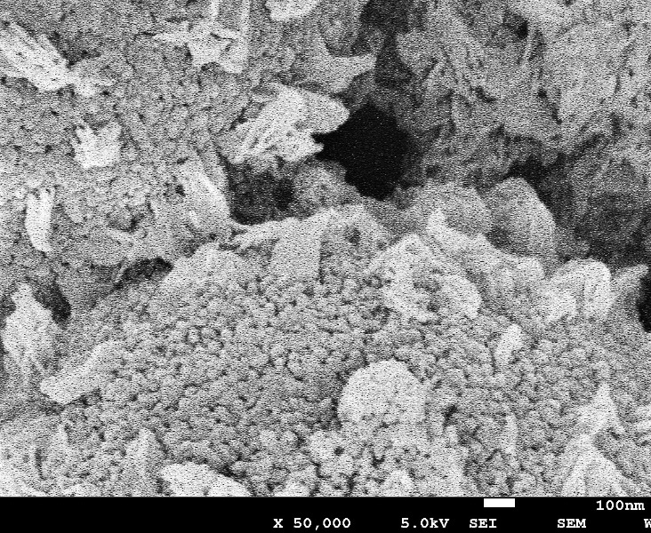
Figure 6. SEM image of the particles prepared according to Example 3.

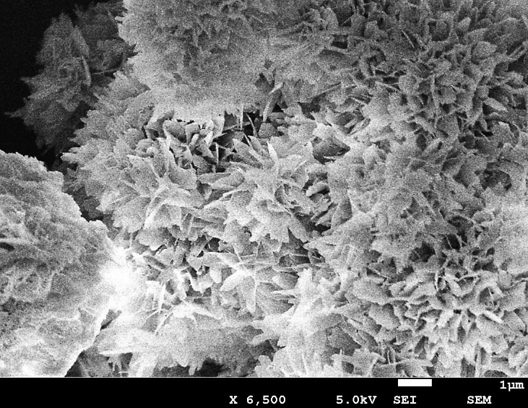
Figure 7. SEM image of the particles prepared according to Example 4.

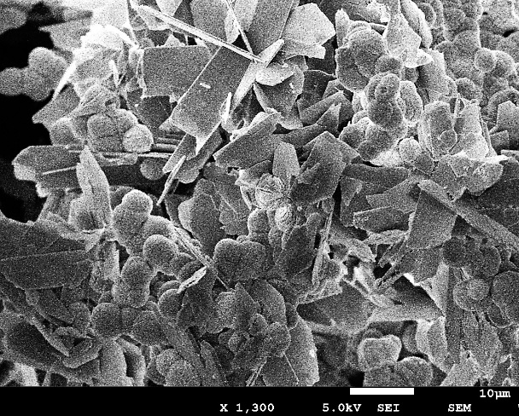
Figure 8. a SEM image of DCPD and calcium carbonate particle blend prepared according to Example 5, prior heating of the reaction mixture.

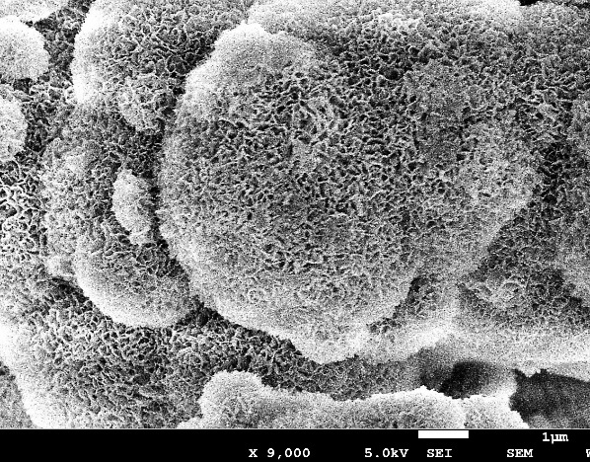
Figure 9. SEM image of the particles prepared according to Example 5, after heating of the reaction mixture and maturation.

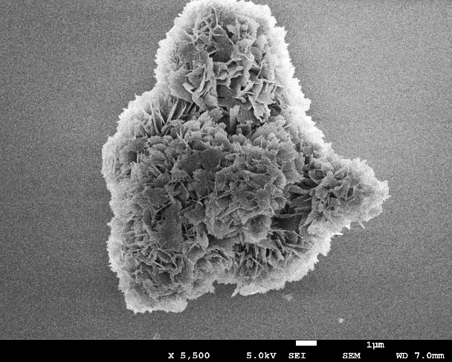
Figure 10. SEM image of the particles prepared according to Example 6.

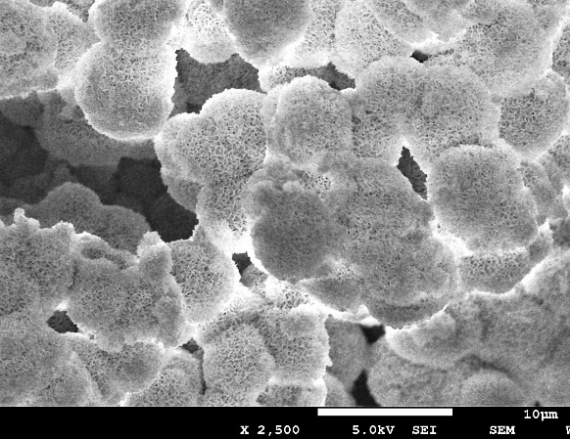
Figure 11. SEM image of the particles prepared according to Example 7.

