1/7
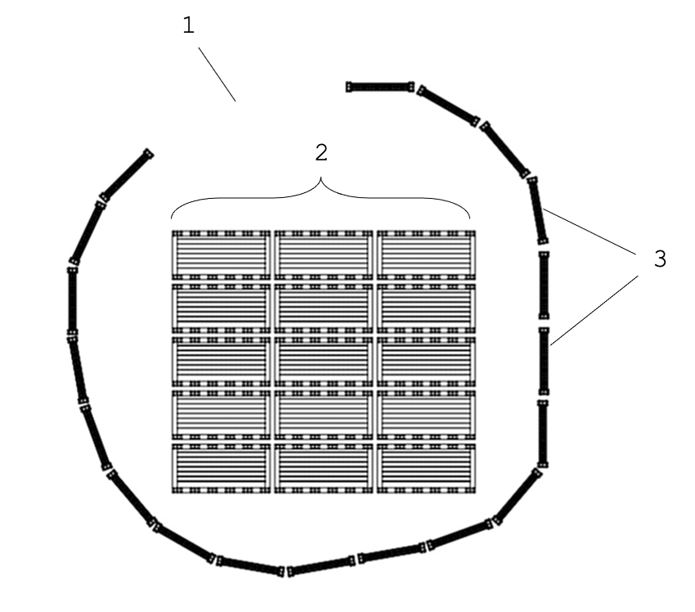

Fig. 1

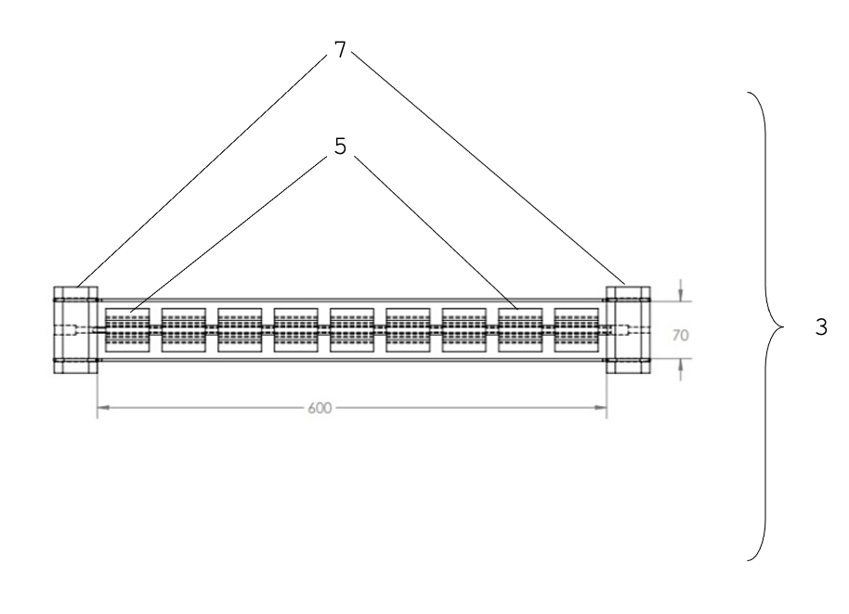

Fig. 2(a)

2/7
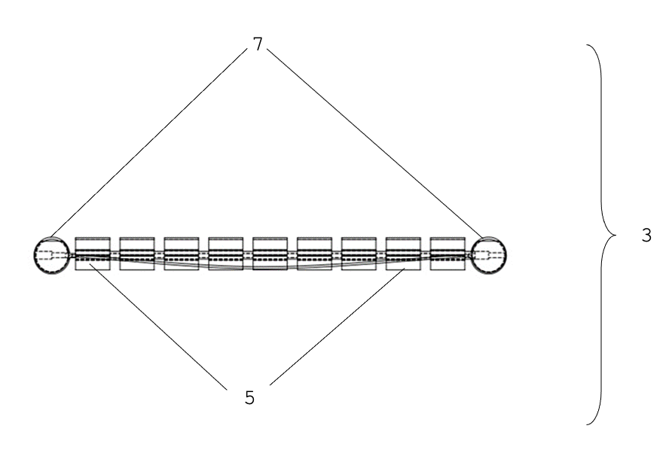

Fig. 2(b)
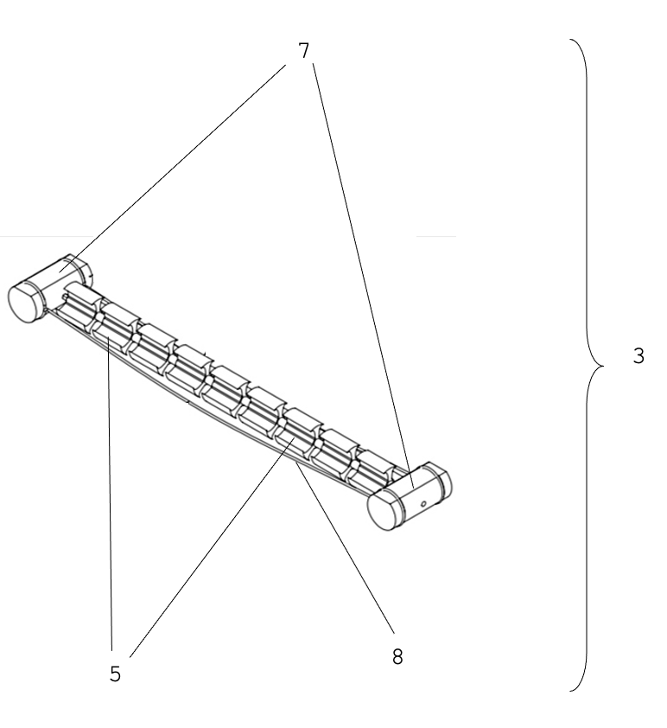

Fig. 2(c)

3/7

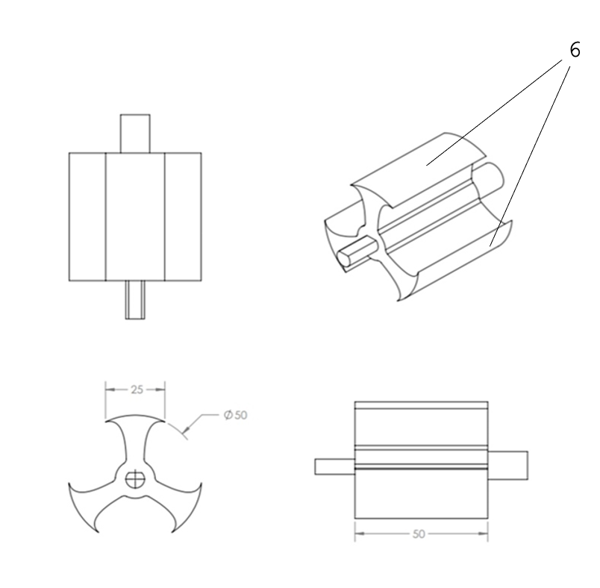

Fig. 3

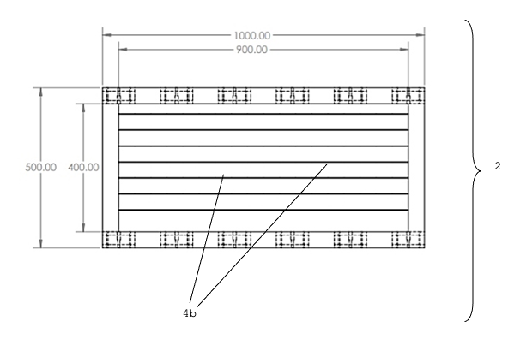
4/7

Fig. 4(a)

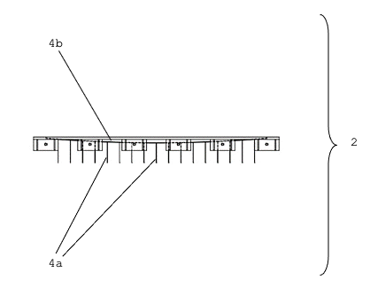

Fig. 4(b)

5/7
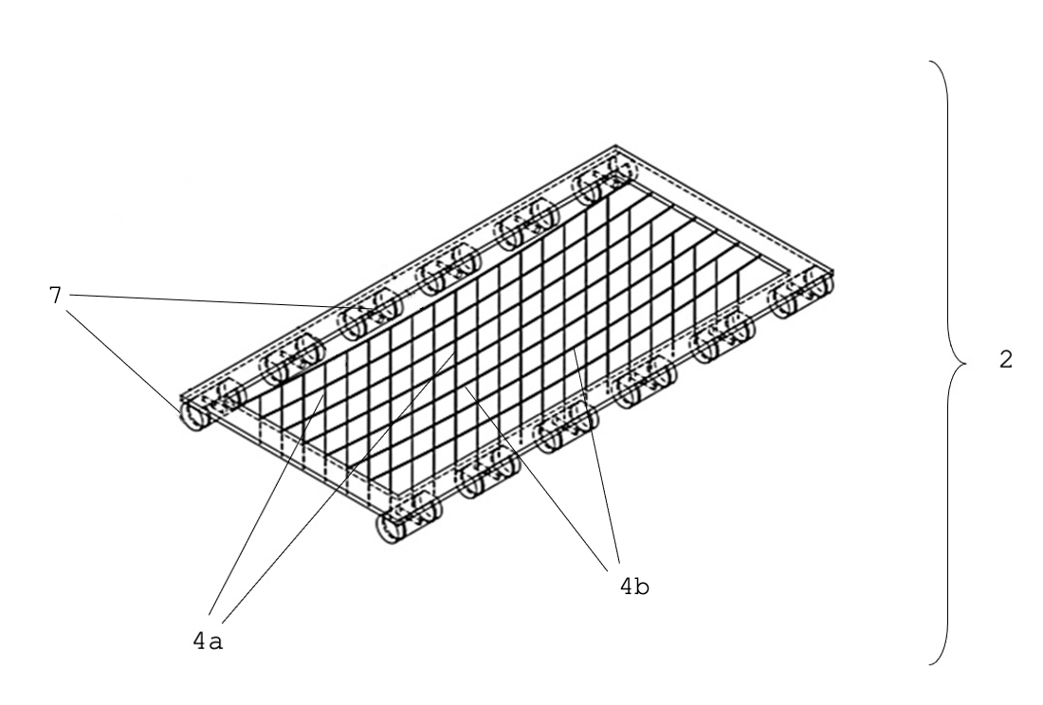

Fig. 4(c)

6/7

Table 1
Bacteria (Probiotic) | Fish tested | Activity
Bacillus licheniformis (TSB27), Lactobacillus thuringiensis, Bacillus Plantarum, Bacillus subtilis (B46) | Sparus aurata L. | Enhancement of the immune system
Shewanella putrefaciens Pdp11 | Solea senegalensis | Modulates the digestive microbiota, an increase in growth
Bacillus pumilus H2 | Fish | Anti-Vibrio activity
Bacillus subtilis WB60 | Anguilla japonica | Increase in weight, efficiency in food and protein
Lac. pentosus BD6, Lac. fermentum LW2, Bacillus subtilis E20, Saccharomyces cerevisiae P13 | Asian seabass | Improves either the growth performance or disease resistance of Asian seabass against A. hydrophila
Pseudoalteromonas sp. | Seriola lalandi | Increase of larval survival
Pseudoalteromonas sp. | Seriola lalandi | Increase of larval survival
Lactobacillus plantarum | Oreochromis niloticus | Decreases mortality and improves growth
Bacillus subtilis, Lactobacillus rhamnosus | Labeo rohita | Increases the value of biochemical components
Lactobacillus casei | Keureling fish (Tor tambra) | Growth performance and feed efficiency increased
Bacillus sp. MVF1 | Labeo rohita | Decreases susceptibility to disease
Bacillus subtilis, Bacillus licheniformis | Juvenile rainbow trout | Enhanced resistance against A. salmonicida
Kocuria SM1, Rhodococcus SM2 | Oncorhynchus mykiss | Produces extracellular enzymes that may have a role in the host digestive processes
Vibrio lentus | Dicentrarchus labrax | Protective effect against Vibriosis caused by V. harveyi in sea bass larvae
Lactobacillus plantarum | Tilapia | Enhances the growth performance and modulated some hematological parameters.

7/7

Bacillus megaterium PTB 1.4 | Catfish | Increases the activity of digestive enzymes and the growth of catfish
Lactobacillus rhamnosus | Pagrus major | Growth-promoting agent and increases growth
Lactobacillus acidophilus, Bacillus subtilis, Lactobacillus bulgaricus, Saccharomyces cerevisiae | C. gariepinus | Increases larval survival
Bacillus megaterium, Bacillus polymyxa, Lactobacillus delbrueckii | Oreochromis sp. | Increases the performance of zootechnical parameters
Enterococcus casseliflavus | Oncorhynchus mykiss. | Improves growth performance and enhancing disease resistance by inmunomodulation
Pseudoalteromonas sp. | Fish | Inhibitory activity against fish pathogens
Pseudoalteromonas sp. Cepa MLms gA3 | Fish | Inhibitory activity against the pathogen V. anguillarum
Bacillus sp., Pediococcus sp. | Solea senegalensis | Improvement protection against pathogen outbreaks and
Lactobacillus plantarum (LP20) | Seriola dumerili | Improves immune response and stress
Lactobacillus mesenteroides SMM69, Weissella cibaria P71 | Scophthalmus maximus L. | Antimicrobial activity against the turbot pathogens T. maritimum and V. splendidus
Bacillus subtilis, Bacillus licheniformis, Bacillus sp., Pediococcus sp. | Oreochromis sp. | Resistance to S. agalactiae
Enterococcus faecalis | Oncorhynchus mykiss | Favouring growth, stimulation of the immune system and protection against diseases

Fig. 5

