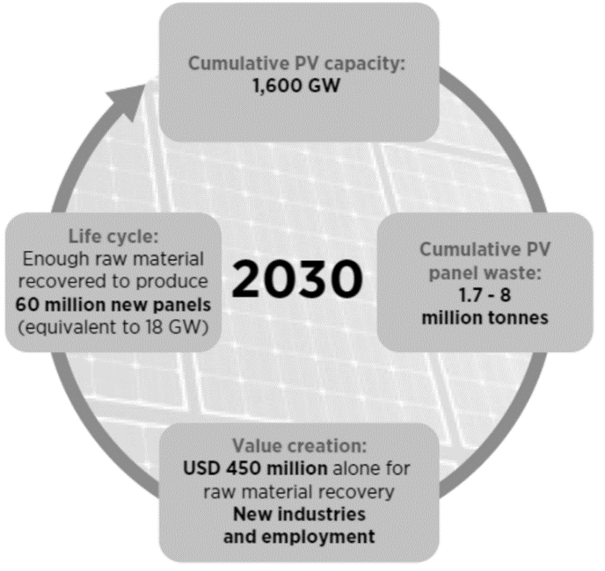
Figure 1. Exemplification of the circular PV economy that this invention seeks to create.
Source: IRENA, IEA-PVPS. End-of-life management: Solar photovoltaic panels, 2016. [1]

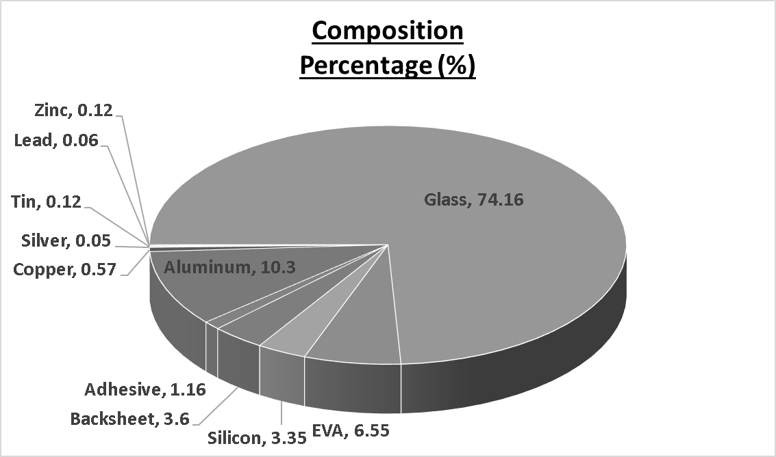
Figure 2. Composition percentage of a typical solar panel. Source: IRENA, IEA-PVPS. End-of-life management: Solar photovoltaic panels, 2016 [1].

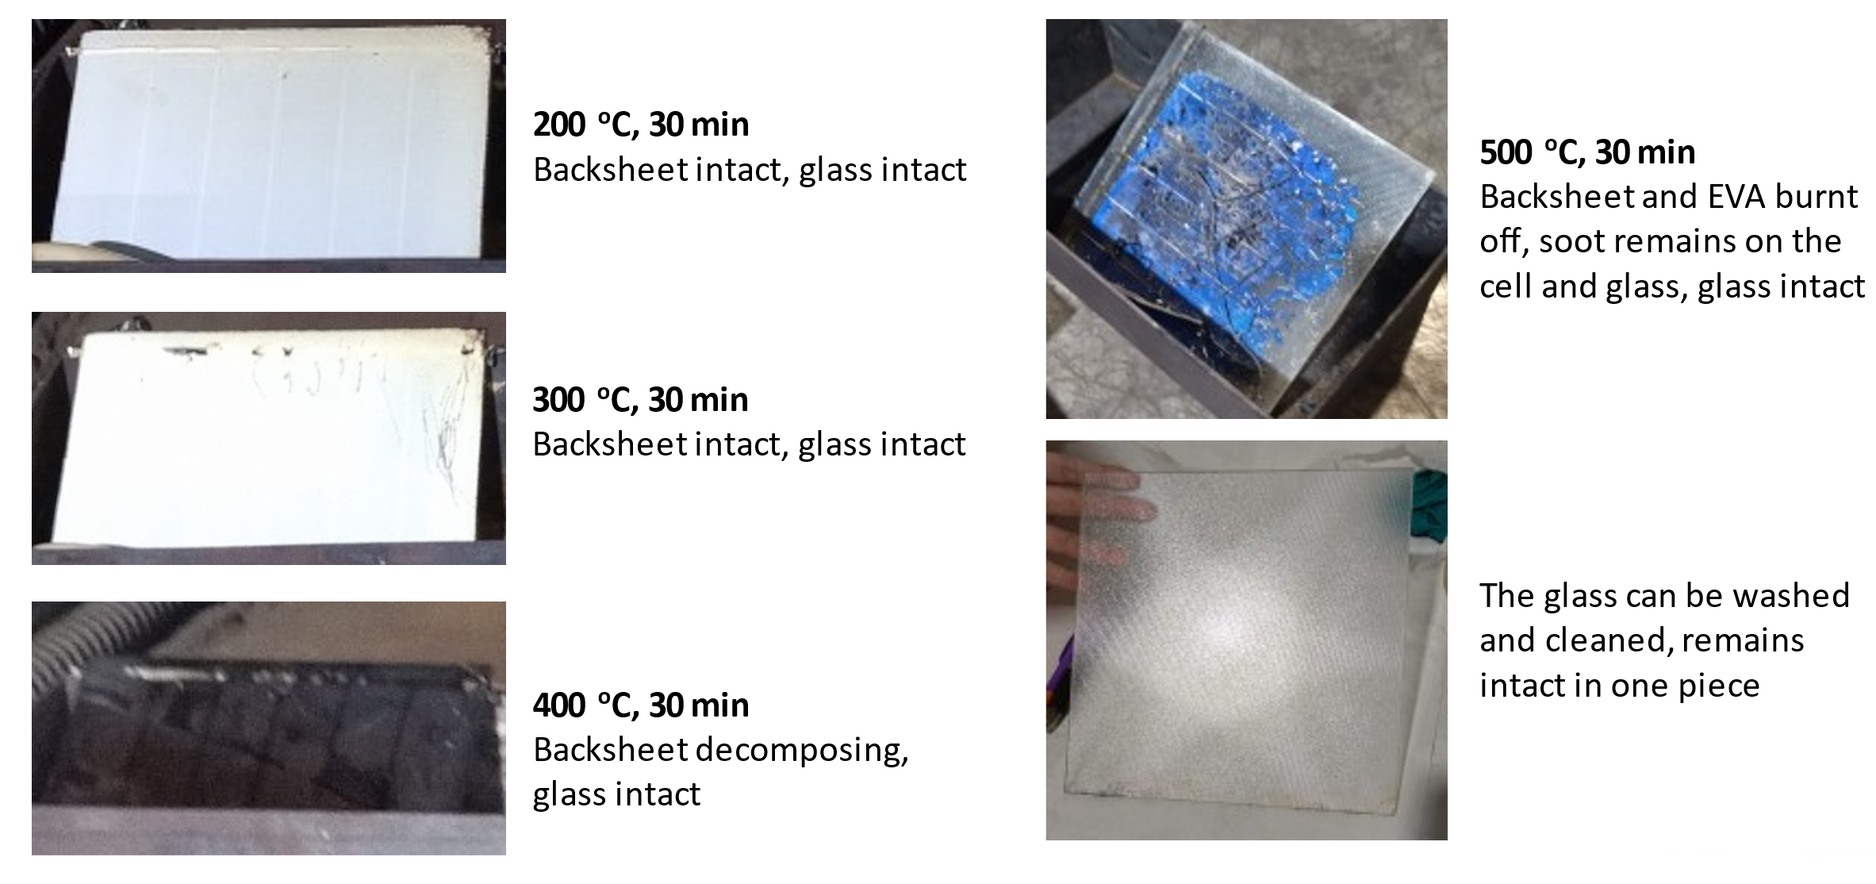
Figure 3. Visual observation of the backsheet and EVA encapsulant after the mini-modules were incinerated in the various as-stated temperatures and durations.

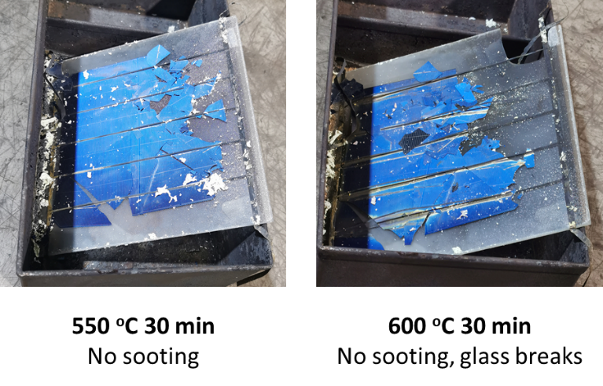
Figure 4. Further optimization studies for the thermal incineration process.

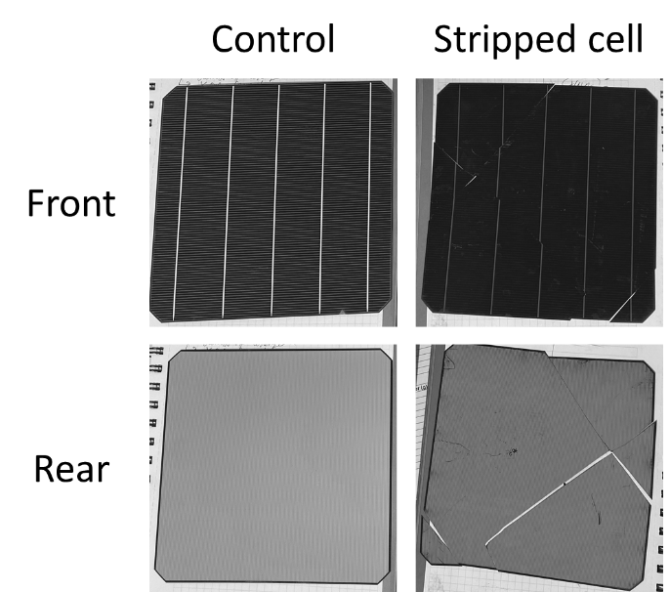
Figure 5. Images showing the cells before and after the stripping process. Note the changes on the busbars and fingers after the stripping process.
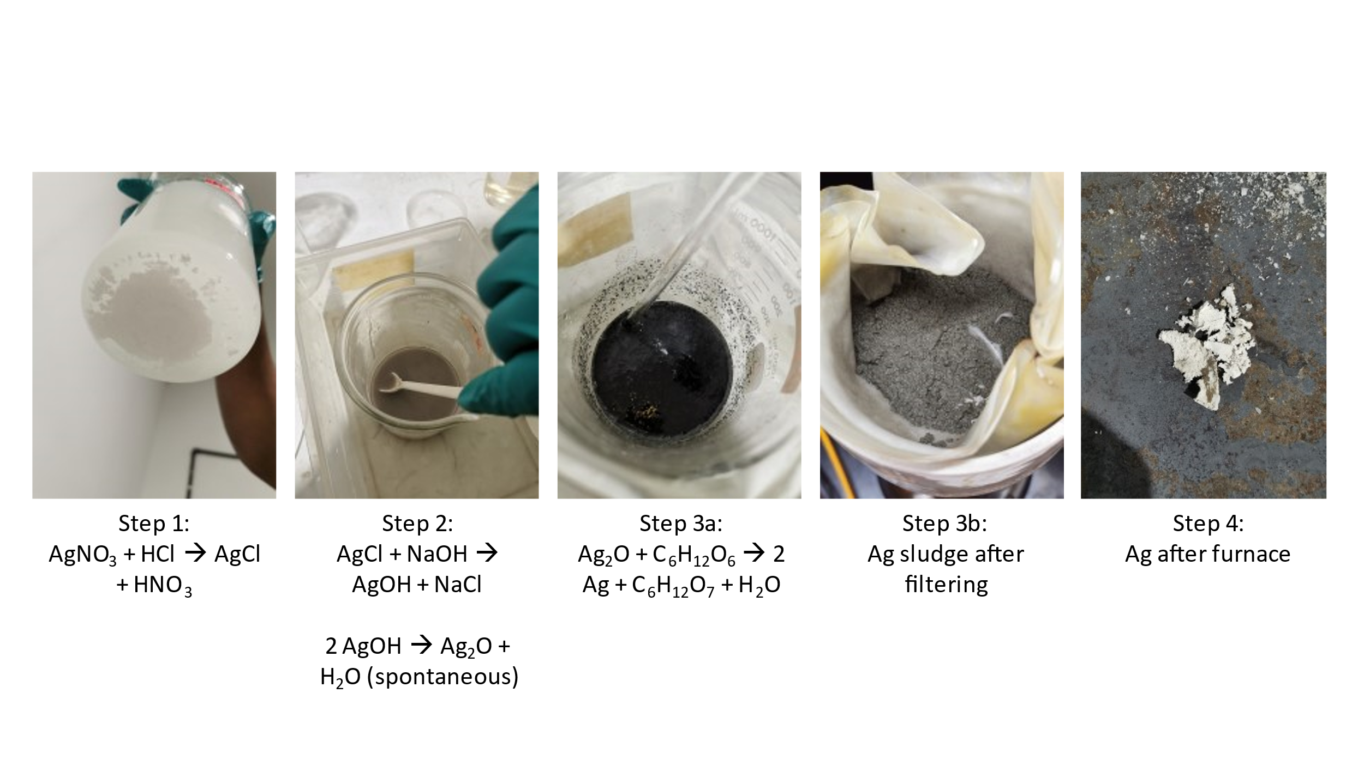
Figure 6. Visual changes that occur with each step of conversion from AgNO₃ into Ag metal.

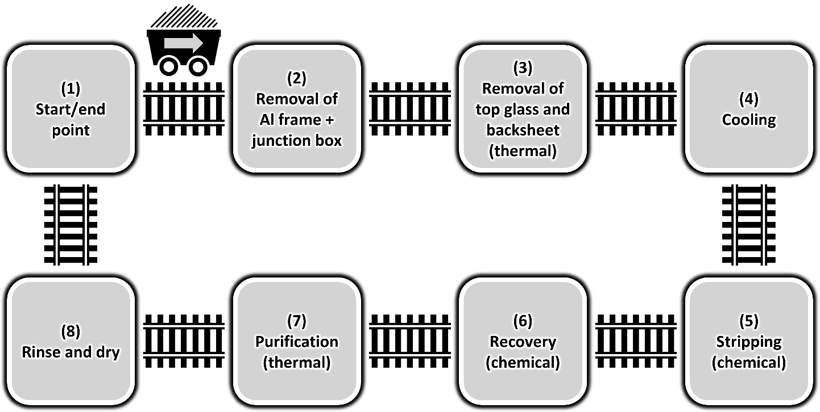
Figure 7. Recycling line concept for solar panels on the industrial scale level.

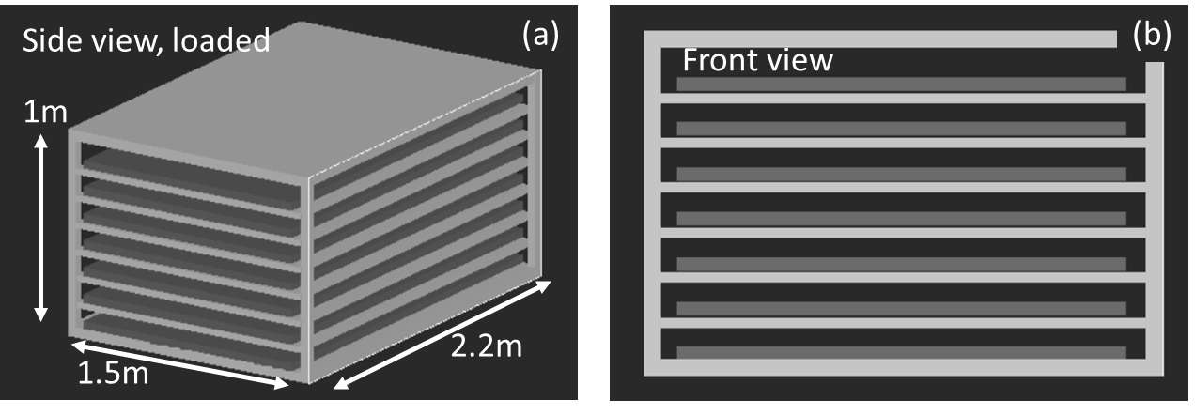
Figure 8. Holder design for thermal process with (a) its side view, and (b) its front view. The blue portions represent deframed solar panels.
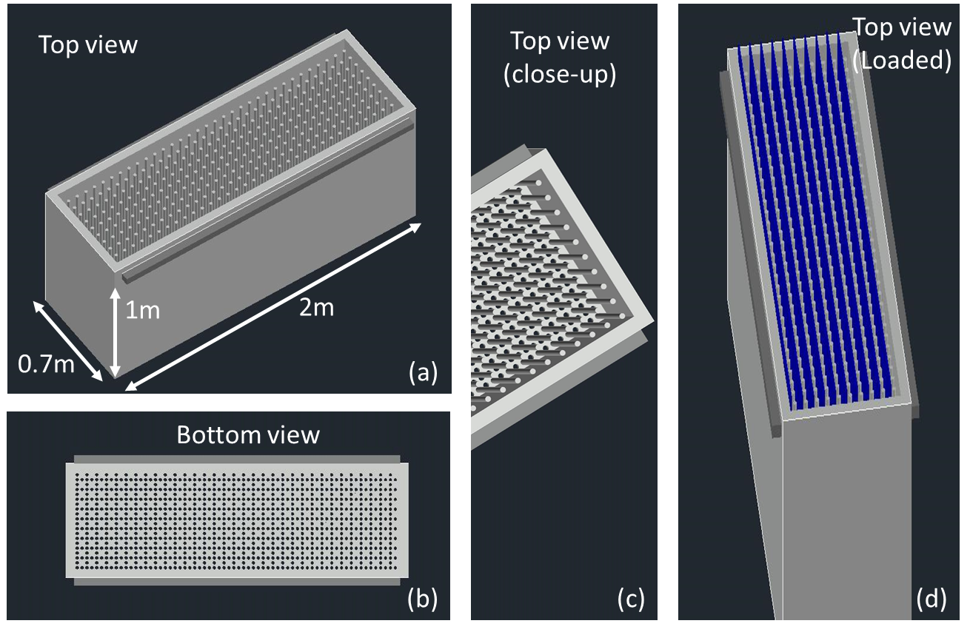
Figure 9. Dimensions of the carrier for the solar cells for the chemical process, with (a) the top view, (b) the bottom view, (c), a close-up of the top view, and (d) a close-up of the top view when the carrier is loaded with solar cells.

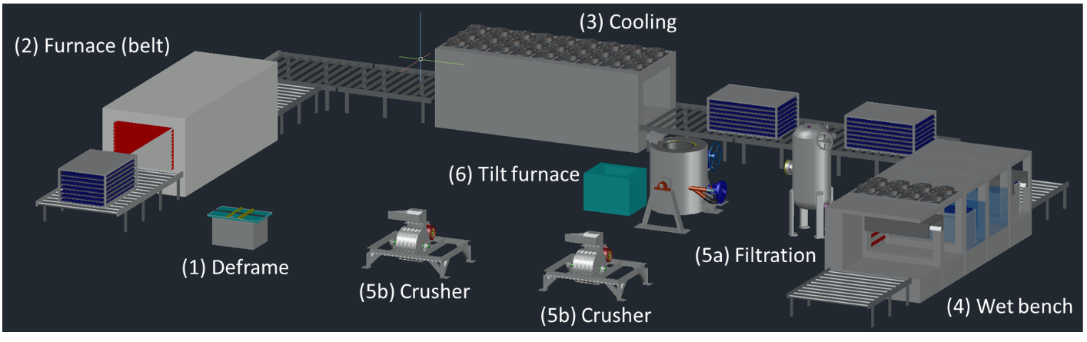
Figure 10. Overview of the PV recycling pilot line layout. It consists of: a deframing machine, a furnace, a cooling station, a wet bench station (chemical station), a filtration system, a tilt furnace, and crushers.
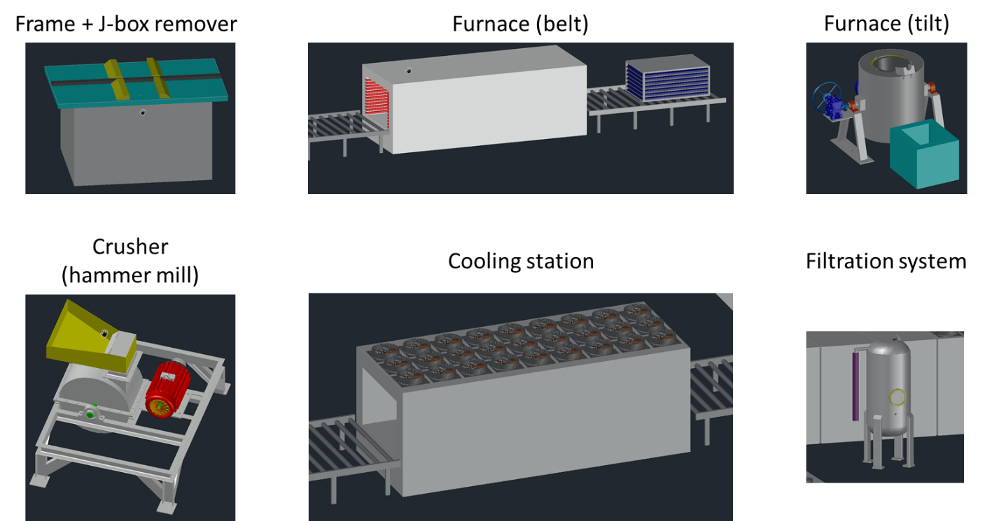
Figure 11. Close up images of the individual tools in the above-described PV recycling pilot line layout plan.

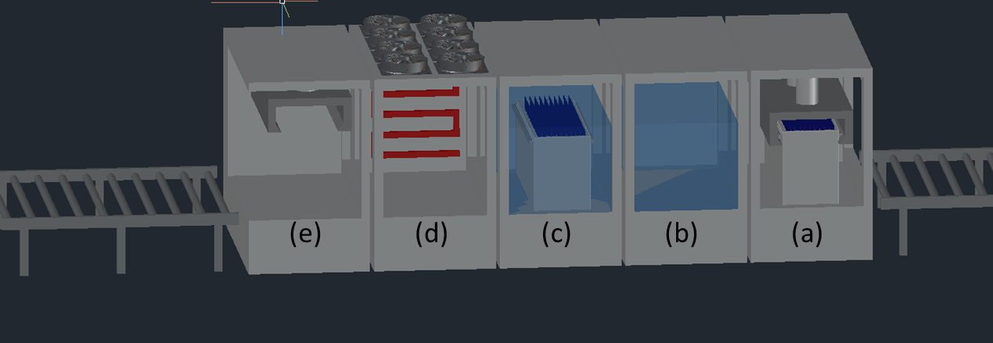
Figure 12. Zoomed in image of the wet bench (chemical process). It consists of: an incoming loading section, a bath container for stripping and recovery, a container for DI water rinsing, a partition for drying, and an outgoing/ unloading section.

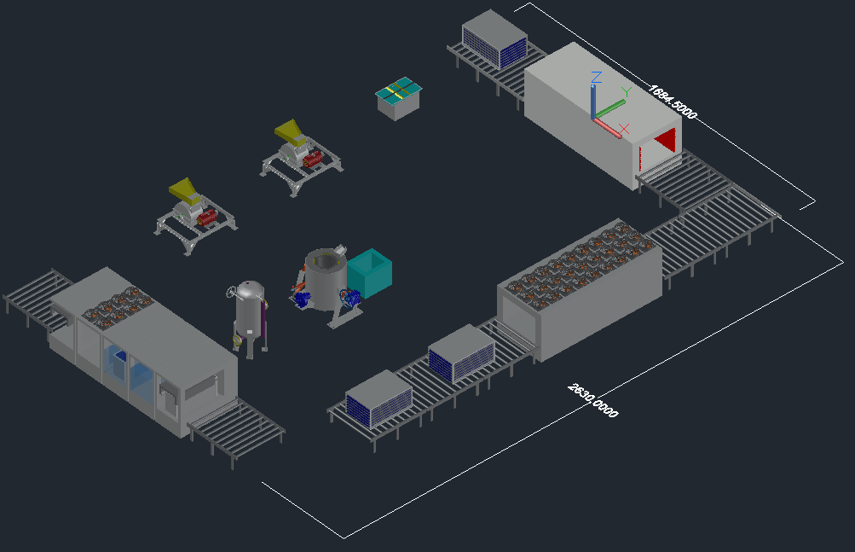
Figure 13. Proposed floorplan layout/ equipment footprint.

