Drawings

Figure 1

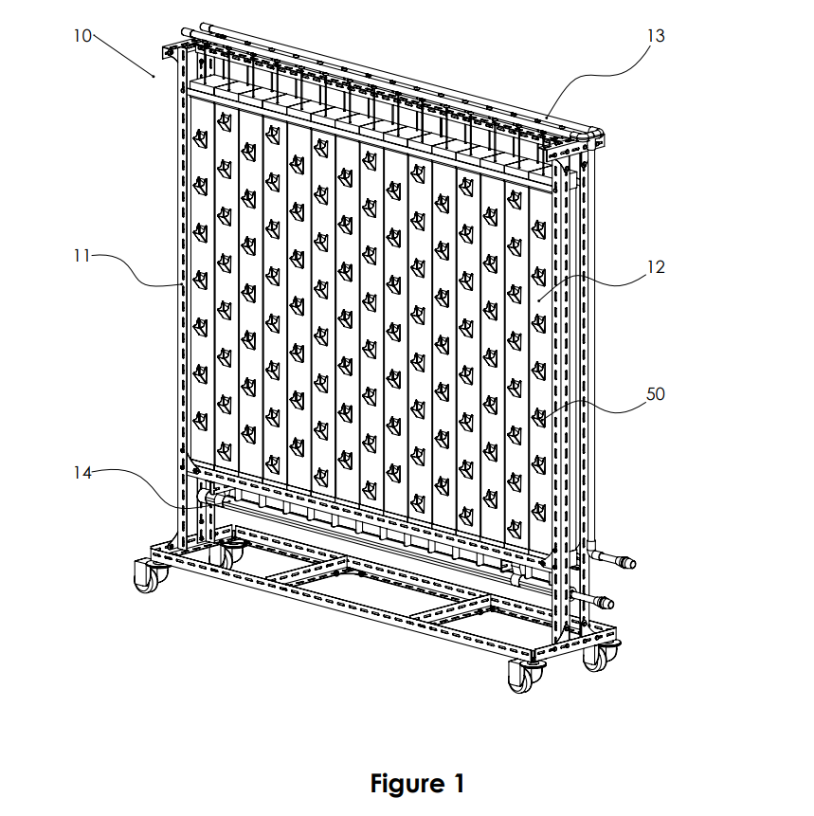

Page 1/7
Figure 2

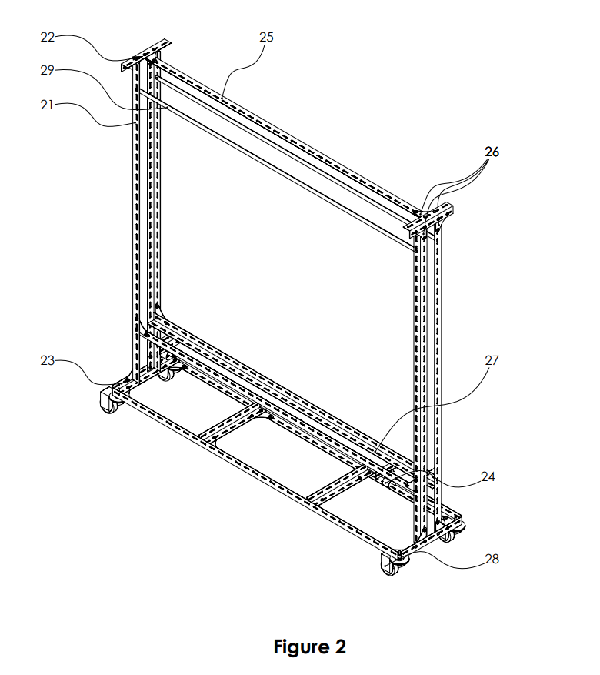

Page 2/7

Figure 3

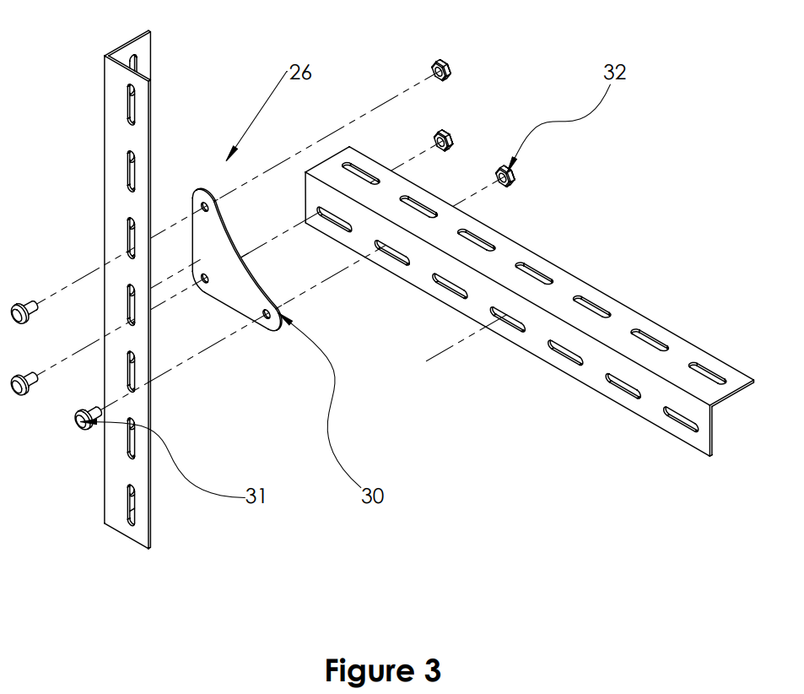

Page 3/7
Figure 4a, 4b, 4c

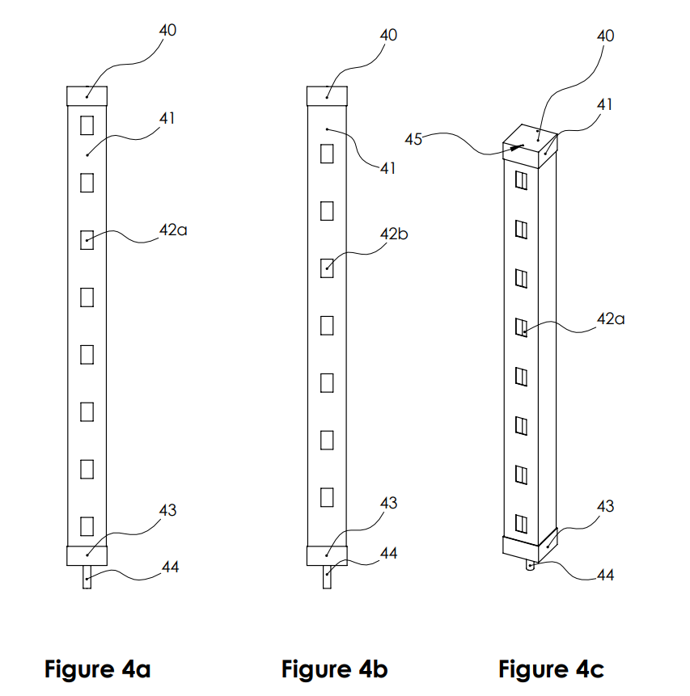 ‘

Page 4/7
Figure 5a, 5b

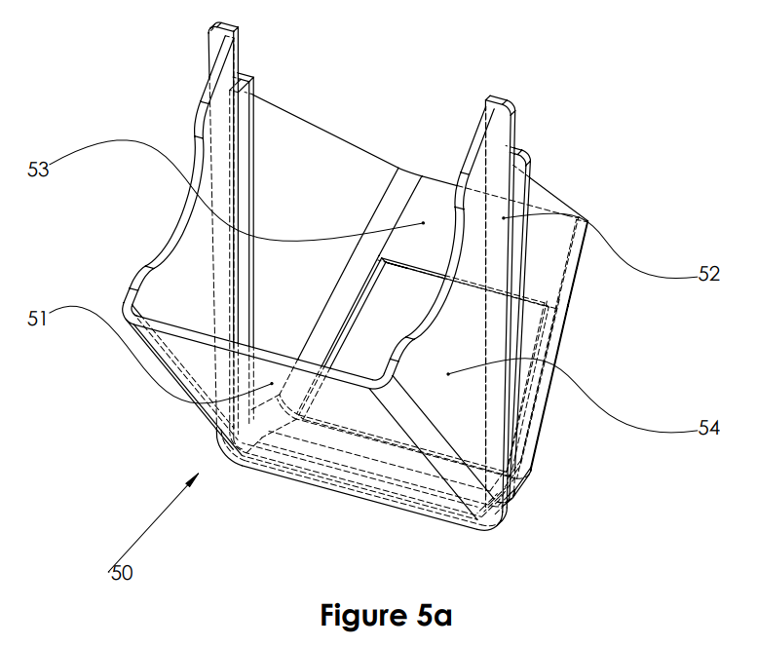
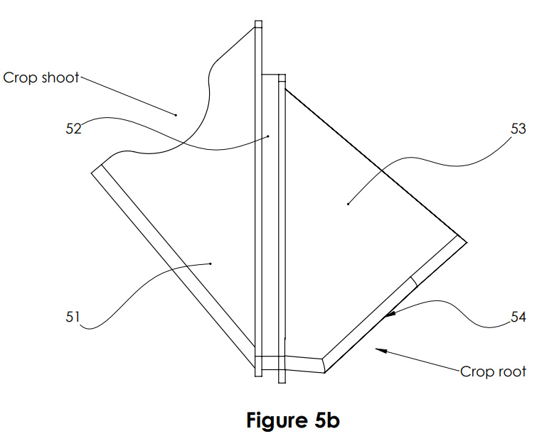

Page 5/7
Figure 6
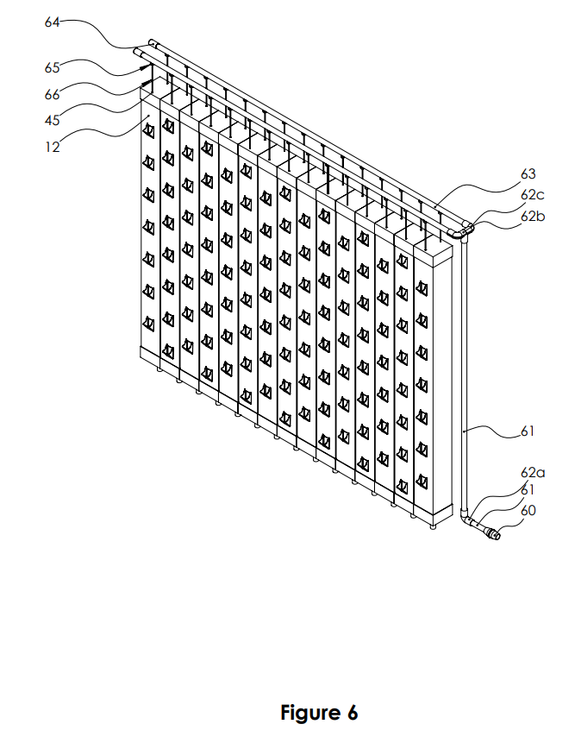

Page 6/7

Figure 7

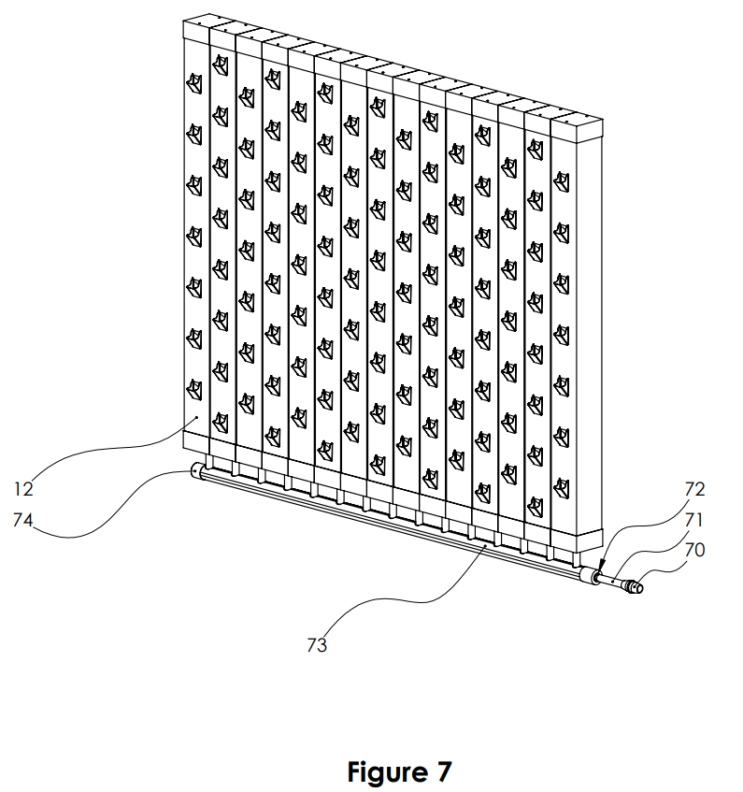

Page 7/7

