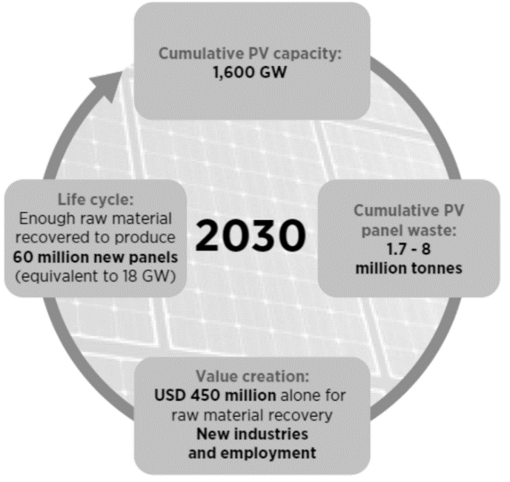
Figure 1. Exemplification of the circular PV economy that this invention seeks to create.
Source: IRENA, IEA-PVPS. End-of-life management: Solar photovoltaic panels, 2016. [1]

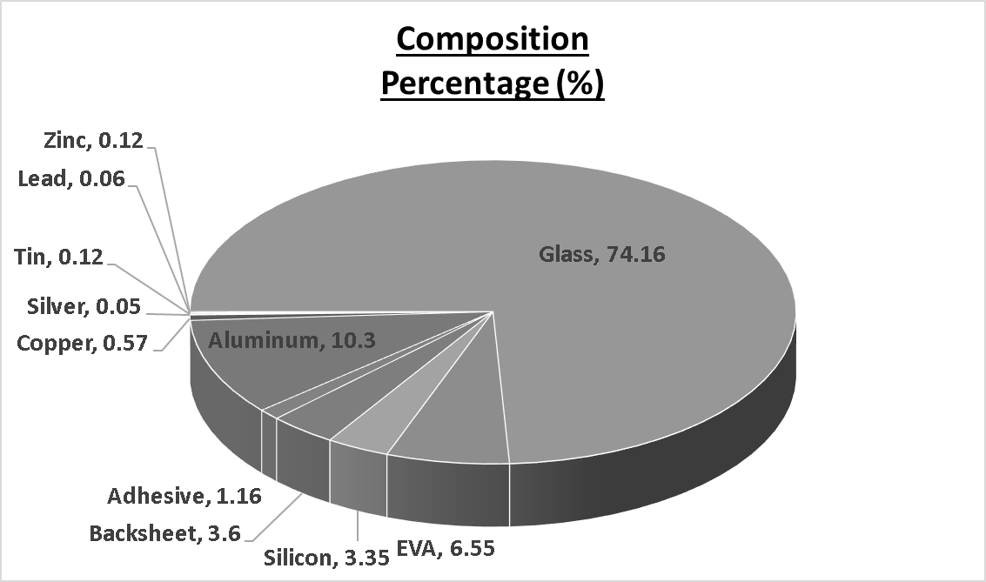
Figure 2. Composition percentage of a typical solar panel. Source: IRENA, IEA-PVPS. End-of-life management: Solar photovoltaic panels, 2016 [1].

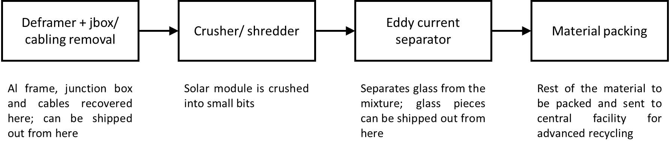
Figure 3. Process flow for the recycling of solar modules within the portable recycling container.

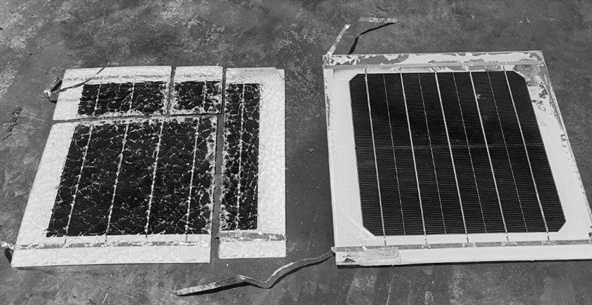
Figure 4. Optical photos of the mini-modules, both sheared successfully (left) and pristine (right). For the sheared mini-module, the cuts by the hydraulic shear machine were observed to be clean. The tempered glass on the mini-module had shattered upon impact, but no flying shards were observed.
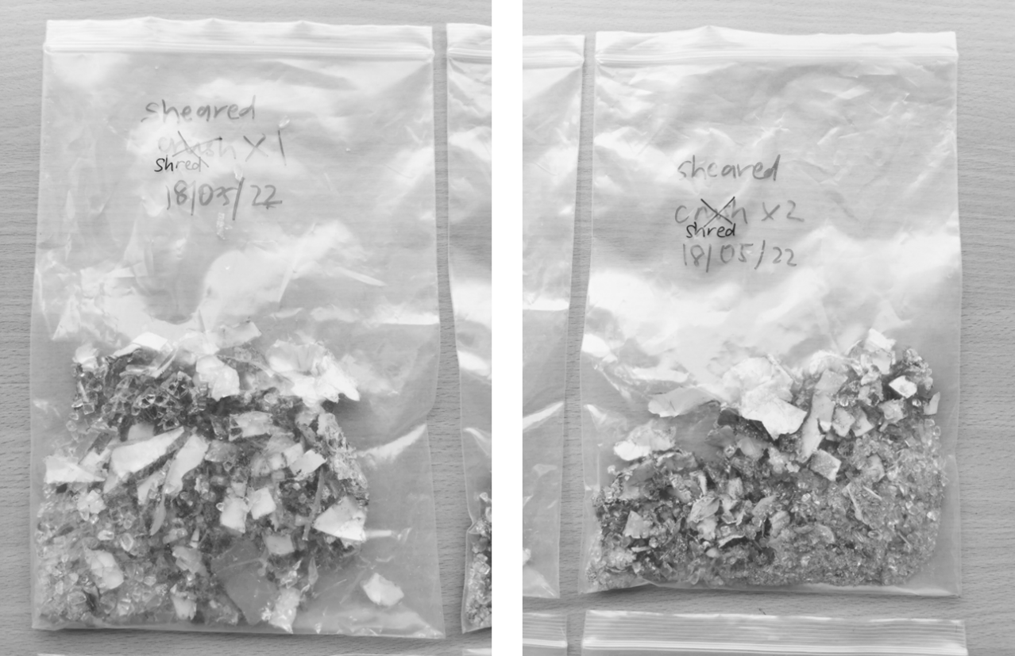
Figure 5. Collected particles for the shredded particles for one shred (left) and two shreds (right).

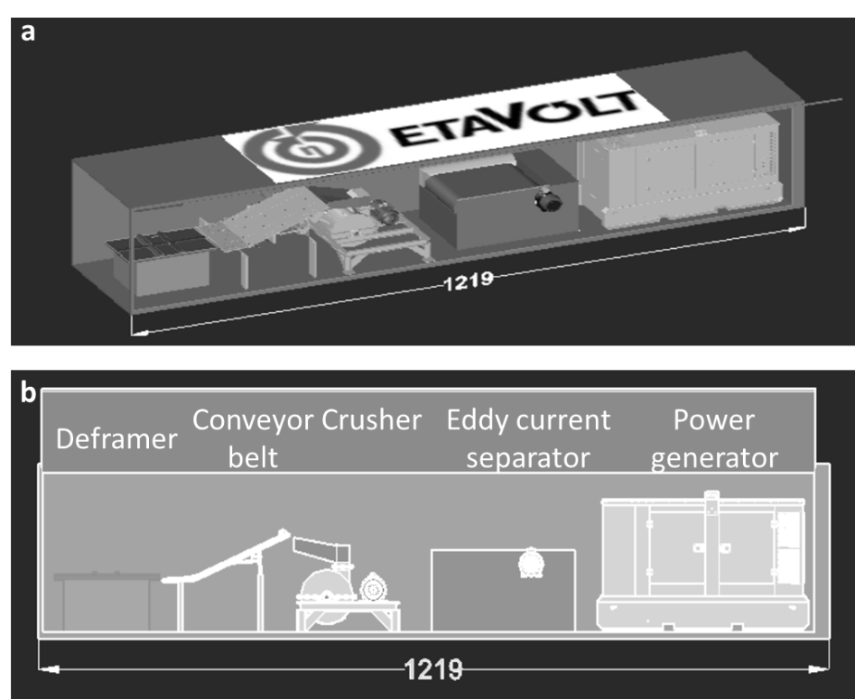
Figure 6. (a) overview of how the mobile recycling unit would look like, and (b) the positioning of each respective tool within the mobile recycling unit.

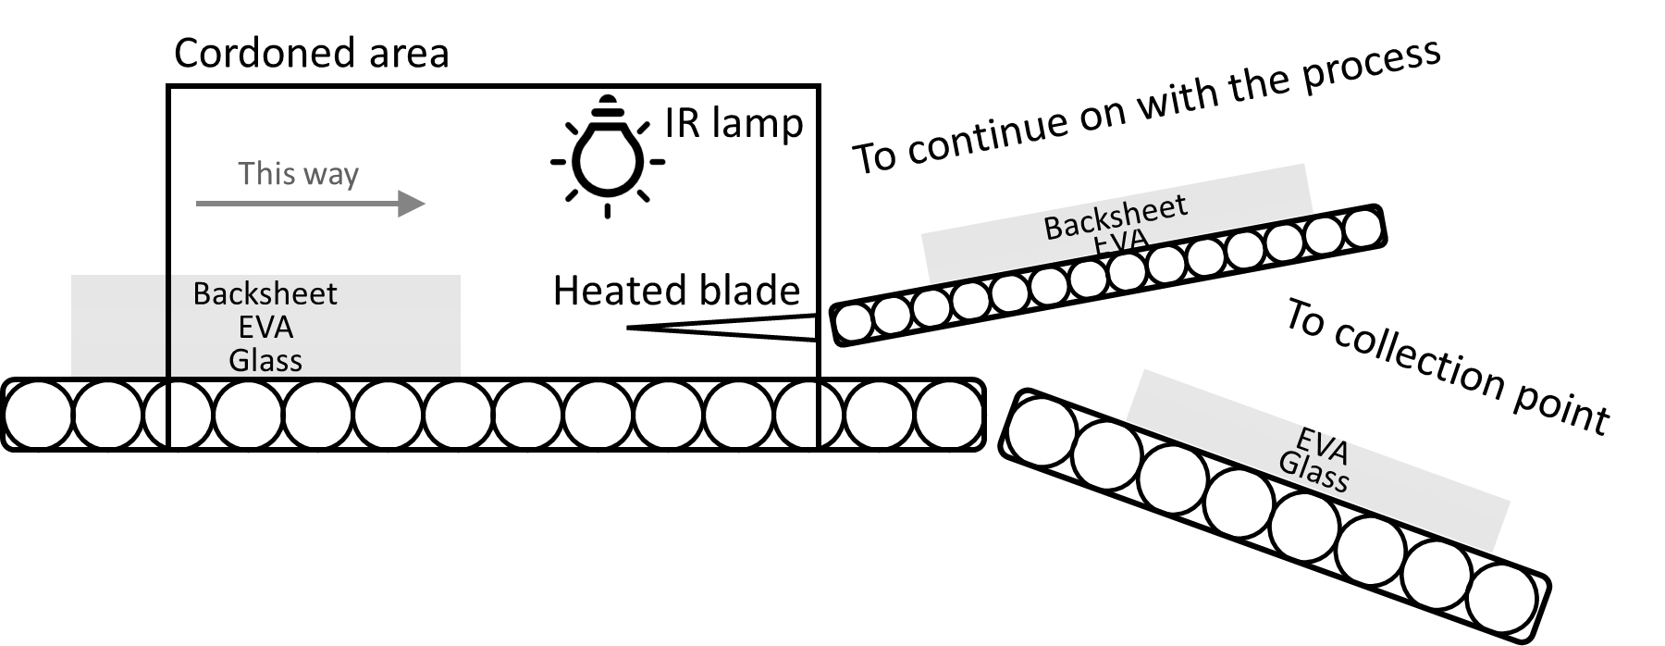
Figure 7. Sample schematic of the thermic detachment process. The conveyor belt brings the deframed solar module from the deframer into the cordoned area. The IR lamp and blade would be pre-heated for at least 10 minutes prior to delamination. Once this is ready, the solar module would travel across the cordoned area into the splitting area, where the heated blade would pierce into the EVA layer while the IR lamp would help to heat this region to aid in the delamination process. When this is completed, the upper layer would be carried off to continue on with the recycling process, and the lower layer would be transported out to a collection point. Depending on the initial configuration from the deframing stage, the configuration of the upper and lower layers would follow suit. Both glass top + backsheet bottom and glass bottom + backsheet top configurations are permissible.

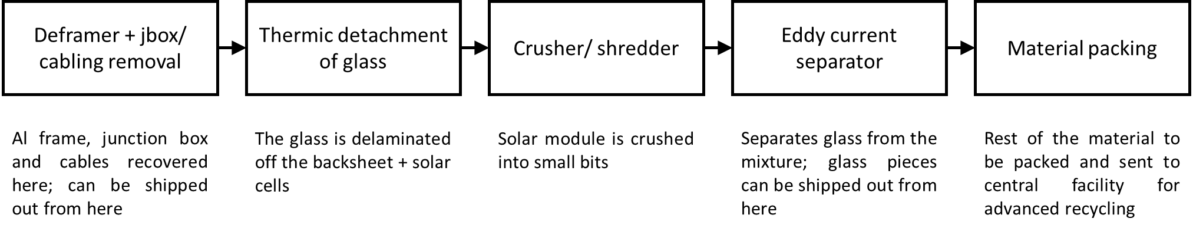
Figure 8. Process flow for the second alternative embodiment.

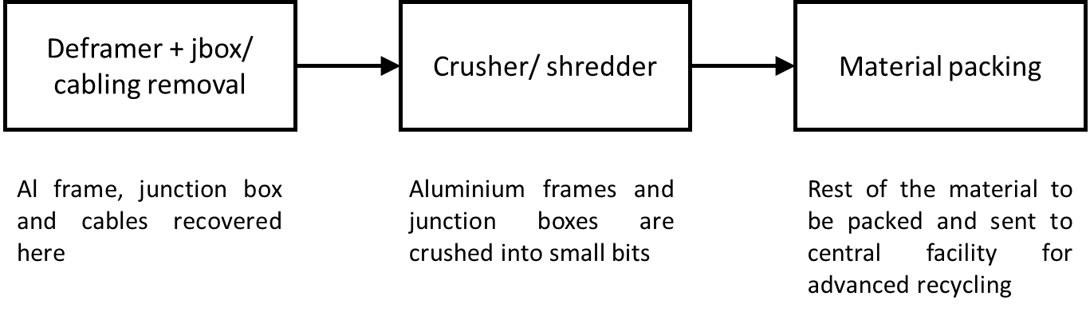
Figure 9. Process flow for the third alternative embodiment.

