Description of Drawings
Heat is generated when there is friction between moving parts due to the conversion of mechanical energy into thermal energy. This phenomenon is a result of the resistance encountered by surfaces in contact as they slide or roll against each other. The generation of heat during friction is a fundamental aspect of physics and plays a crucial role in various engineering and everyday scenarios.

When two surfaces come into contact and start moving relative to each other, the irregularities at the microscopic level of the surfaces interact. These irregularities can be likened as tiny hills and valleys or asperities on the surfaces as shown in diagram 1 of the detailed drawings.

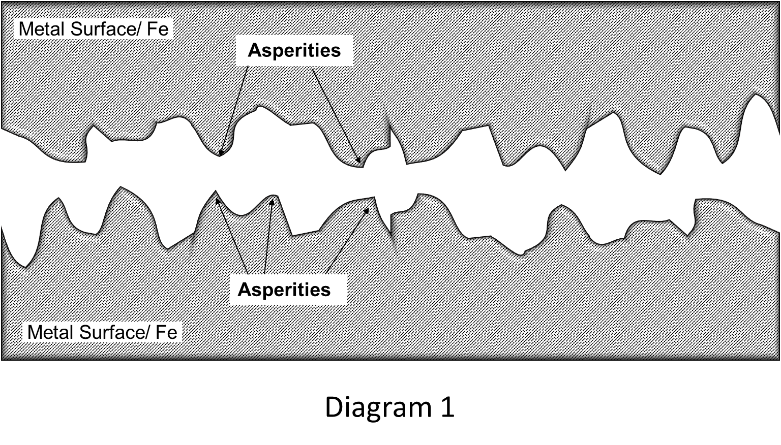
As the surfaces move, these irregularities interlock and then break free, leading to the resistance known as friction as shown in diagram 2 of the detailed drawings.

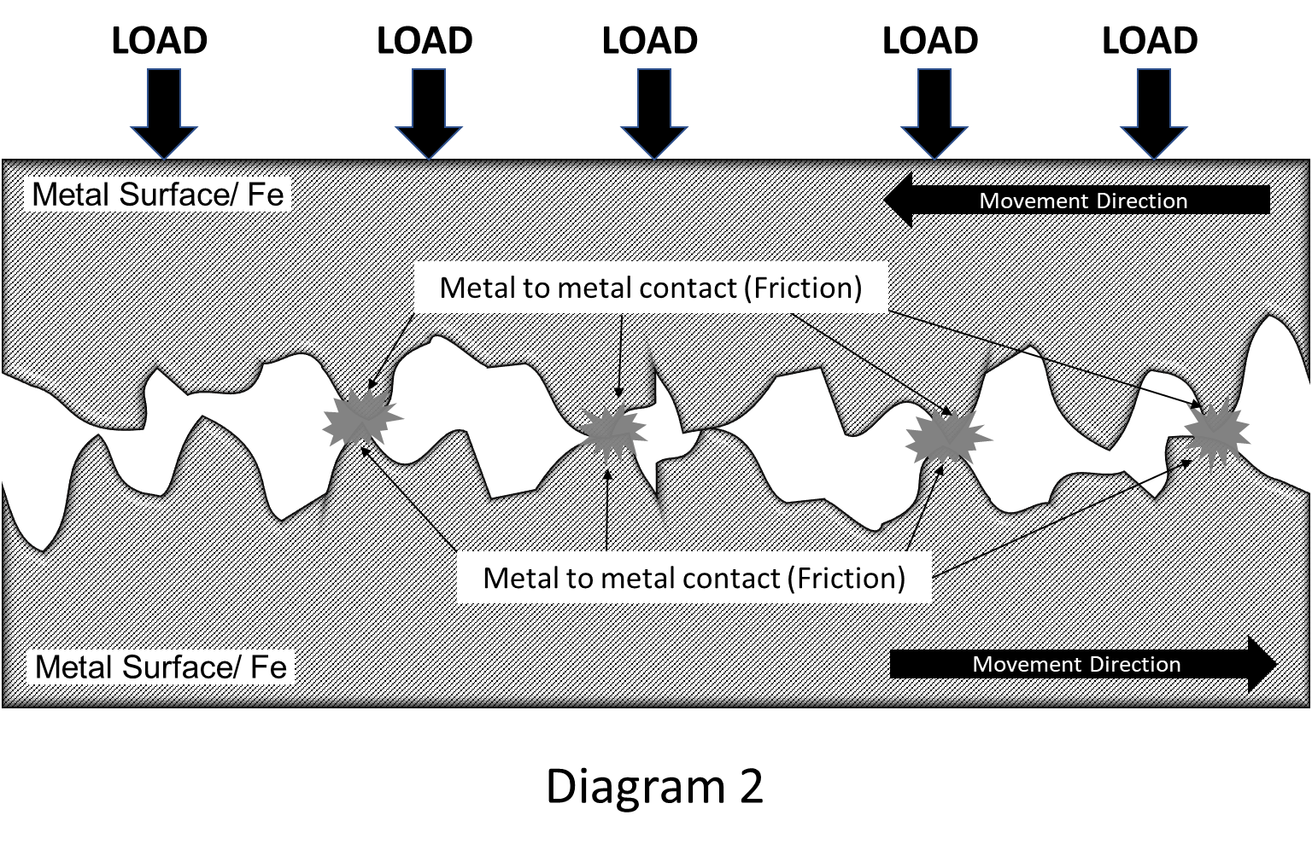

When surfaces slide or roll against each other, these interactions involve deformation and reformation of surface asperities, which results energy dissipation and the conversion of mechanical energy into heat energy and dispersed into the surrounding environment as heat as shown in diagram 3 of the detailed drawings.

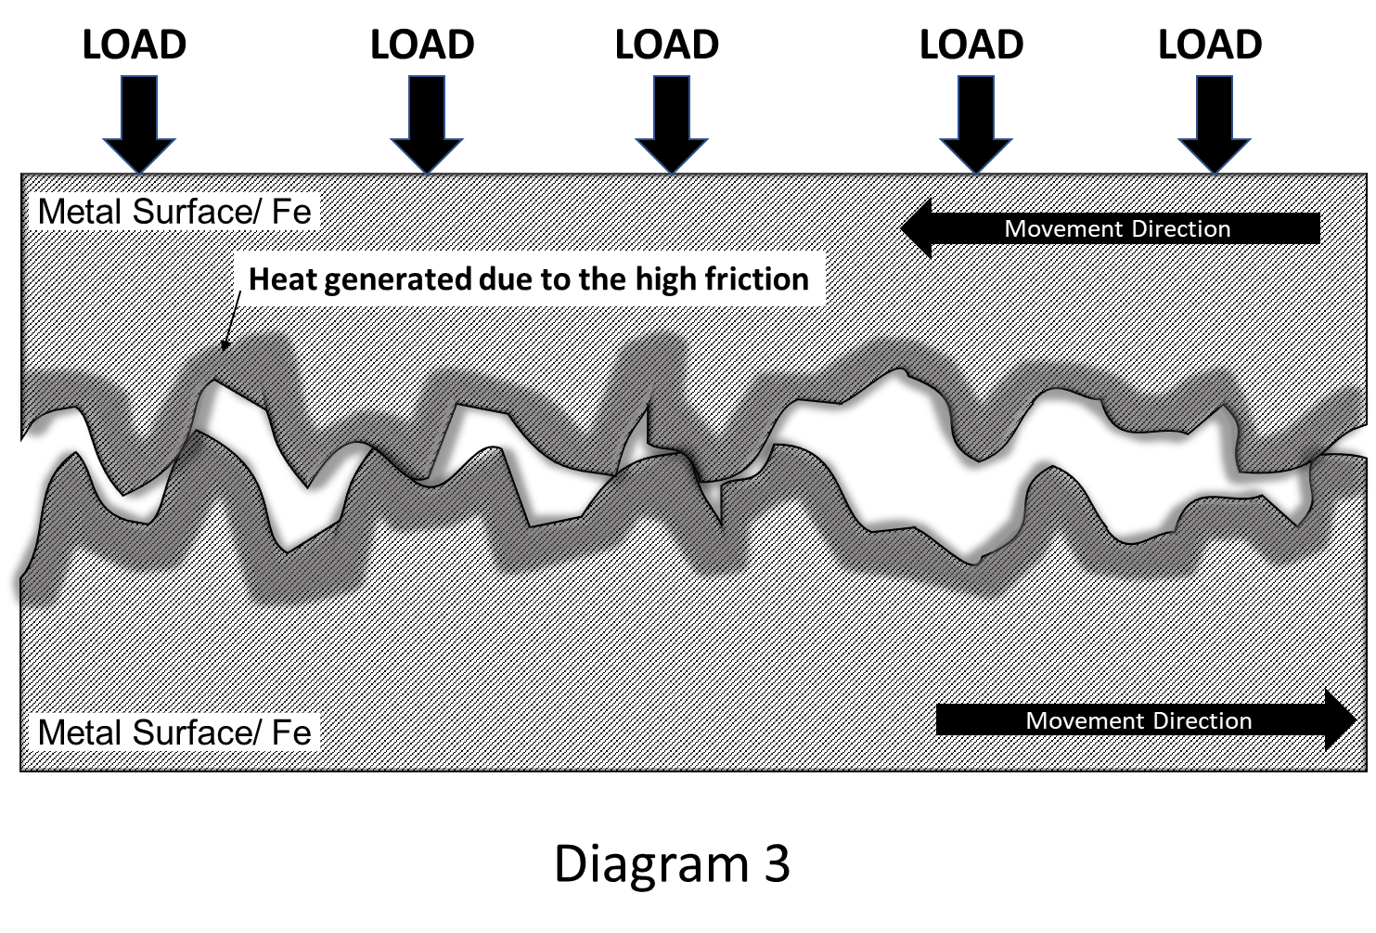

When the heat generated by friction continues to increase, it leads to the seizing of moving parts. Seizing happens when components become stuck or locked together due to the intense heat and friction, resulting in the machine or engine ceasing to function, as shown in diagram 4 of the detailed drawing.

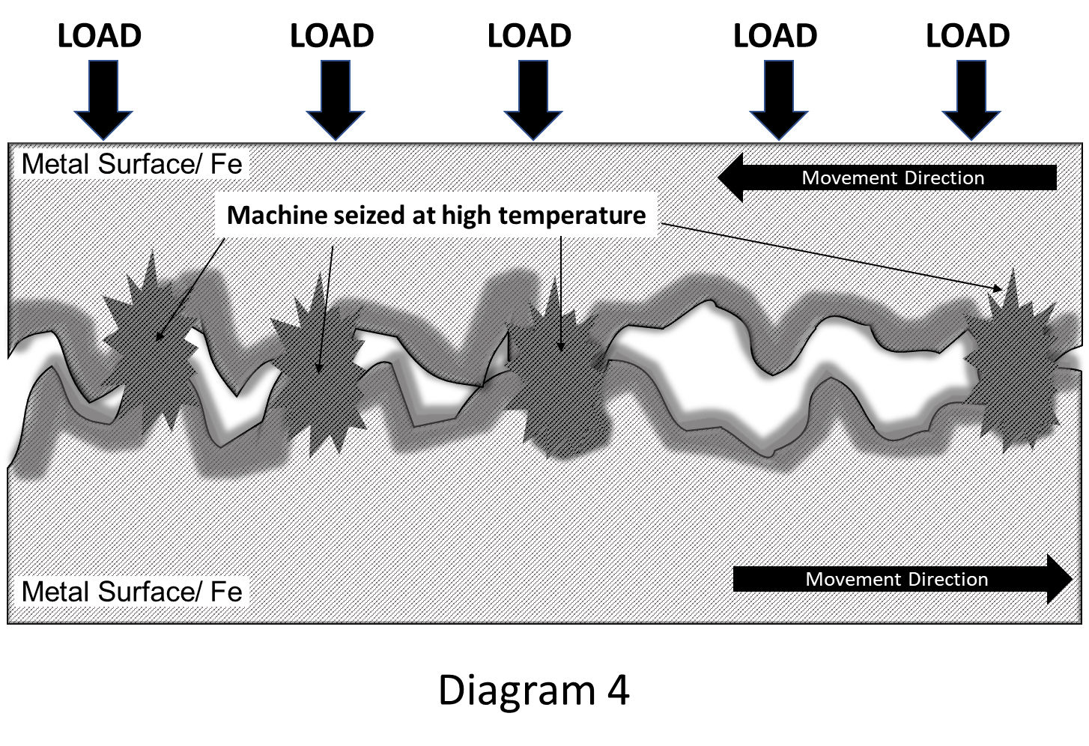

Physical adsorption
S
S
R
COOR
R
COOR
R
COOR
Metal Surface/ Fe
S
R
COOR

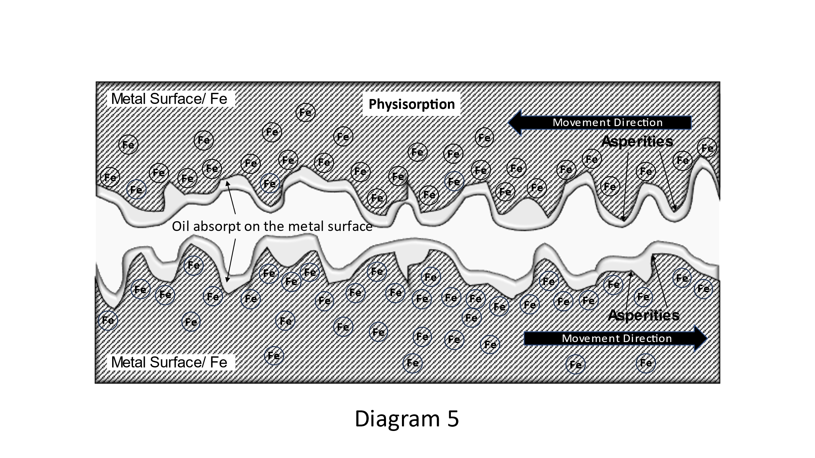
Diagram 5

Diagram 6
Physical Adsorption (Physisorption): Physisorption involves weak intermolecular forces, such as van der Waals forces, between the adsorbate (sulphur molecules) and the adsorbent (metal surface). This type of adsorption is generally reversible and occurs at relatively low temperatures. In the case of sulphur interacting with metal surfaces, physical adsorption can involve sulphur molecules being attracted to metal atoms due to van der Waals forces as shown in the schematic diagram 5 and diagram 6 of drawing description.

Chemisorption
R
COOR
R
COOR
R
COOR
R
COOR
S
S
S
S
Metal Surface/ Fe
+
+
+

Diagram 7

Diagram 7

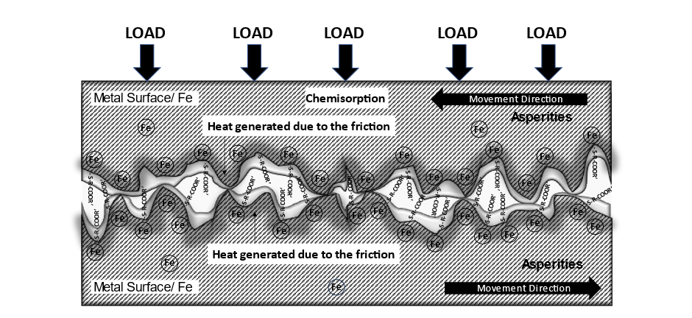
Diagram 8

In contrast, chemisorption entails the establishment of robust chemical bonds between the adsorbate and the adsorbent. This procedure generally demands elevated activation energy and exhibits a more distinct specificity. In the realm of sulphur interaction with metal surfaces, chemisorption encompasses the generation of chemical bonds between sulphur and the metal surface. This interaction frequently entails atoms like iron, as depicted in diagram 7 and diagram 8 the detailed drawing description.
Sulphur cleavage reaction
R
COOR
R
COOR
R
COOR
R
COOR
S
S
S
S
Metal Surface/ Fe
+
+
+

Diagram 9

Diagram 9

+
+
+
R
COOR′
R
COOR′
R
COOR′
R
COOR′
S
S
S
S
S
S
S
S
S
S
S

FeS
FeS
FeS
FeS
FeS
FeS
FeS
FeS
Metal Surface/ Fe
Fe
Fe
Fe
Fe
Fe
Fe
Fe
Fe
Fe
Fe
Fe
Iron sulphide layer
Sulphur atoms cleavage from Sulphurised ester

Diagram 10

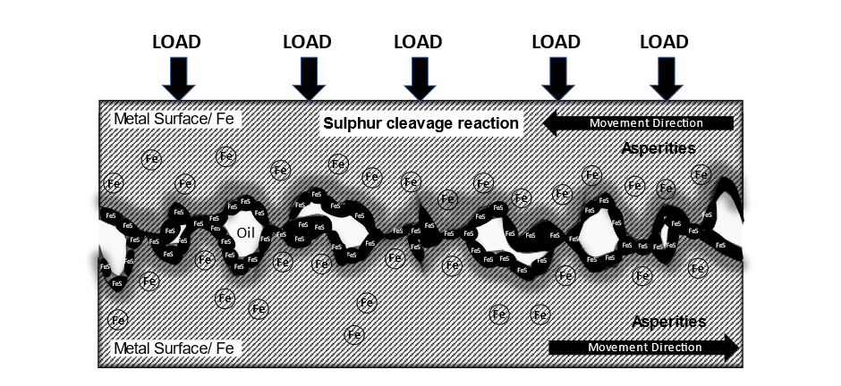

Diagram 11

At high load and temperature, the sulphurised ester reacts with the metal surface and form sacrificial monomolecular inorganic Iron Sulphide boundary films, that protect bulk metal against wear damage as shown in diagram 9, 10 and 11 of the detailed drawing description.
To prevent the development of larger regions of direct metal-to-metal contact, which can lead to wear, it is necessary for a new layer metal sulphides to be generated through the reaction of a synergistic blend of sulphurised esters, biobased oils, aminic antioxidants, corrosion inhibitors, and white oil within the frictional area. This layer should form after the degradation of the existing layer but before any additional mechanical stress transpires. Hence, the said synergistic blend of sulfurized ester promptly engage with the metal to ensure this process.

