Abstract
The invention pertains to an Immersive Exhibit Experience System tailored exclusively for musical boxes, seamlessly combining virtual reality (VR) components and real-time 3D rendering software. The system revolutionizes exhibit engagement by providing patrons with a multi-sensory encounter, integrating distinct sound and touch sensory interactions. Users can physically step into virtual exhibit spaces, offering an unprecedented level of immersion. The system allows patrons to selectively choose exhibits, tailor their immersive encounters, and activate unique pre-recorded musical pieces associated with each exhibit. Dynamic adjustment of settings, thematic selections, and touch interactions further enhance the overall experience, providing a customizable and evolving encounter. This invention marks a paradigm shift in the museum and exhibit domain, forging a profound connection between patrons and musical box exhibits while preserving their unique auditory and tactile aspects.

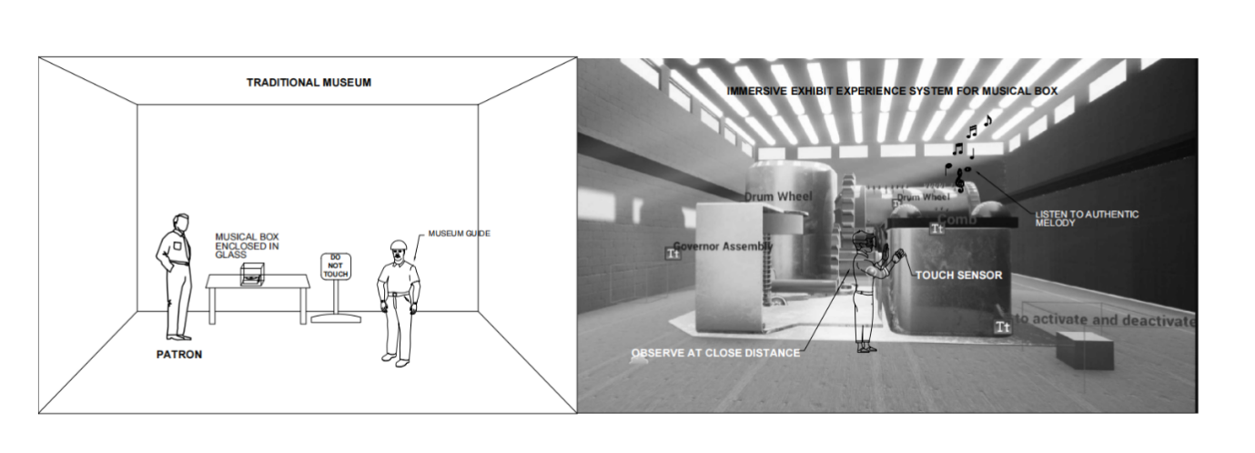
Figure 12: Comparative Narratives

